Advice Online

SmartPanels for the Report Builder

The Report Builder allows the creation of Reports with a combination of text, charts and graphs (to demonstrate the modelled results of any plan). These charts and graphs are referred to as SmartPanels.

This document lists all the SmartPanels already created for the Report Builder. They are grouped in categories.

Please review the Table of Contents and click on those you are interested in to view them.

This guide should be used in conjunction with the How to Create Reports using the Report Builder guide.

SmartPanels have been created so that you can customize your reports to include only the information you require. The only coded reports are Financial Position at Start of Plan and the Fact Find Summary

The SmartPanels have been grouped into categories in this guide, followed by a sub-section of that category. To assist you in locating the SmartPanels you require when designing a report, notes have been added to each category where applicable. Please review the table of contents, to familiarize yourself with the main categories and subcategories.

Some Smart Panels have an second version called Interactive SmartPanel. You have the option to use the regular SmartPanel or the Interactive one. The Interactive panel has the same name with *** after the name. Interactive panels included images. Here are examples:

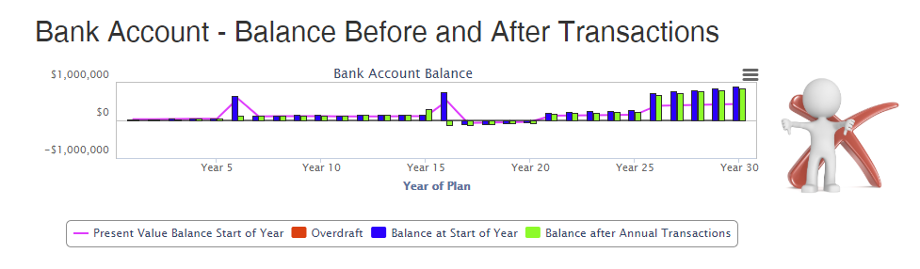

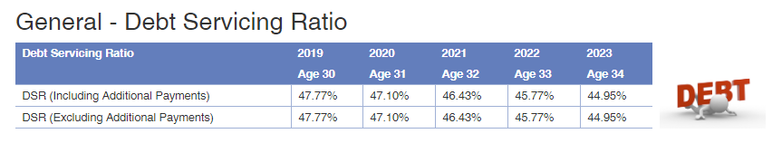
The full list of interactive graphs is:

- Bank Account – Balance Before and After Transactions ***
- Bank Account – Balance at End of Year ***
- General: Debt Servicing Ratio ***

In addition, you can include images in your reports. Refer to the last section of this report. A copy of these images and the ASIC MoneySmart Thumbnails are provided in the Word Document, SOA Images.

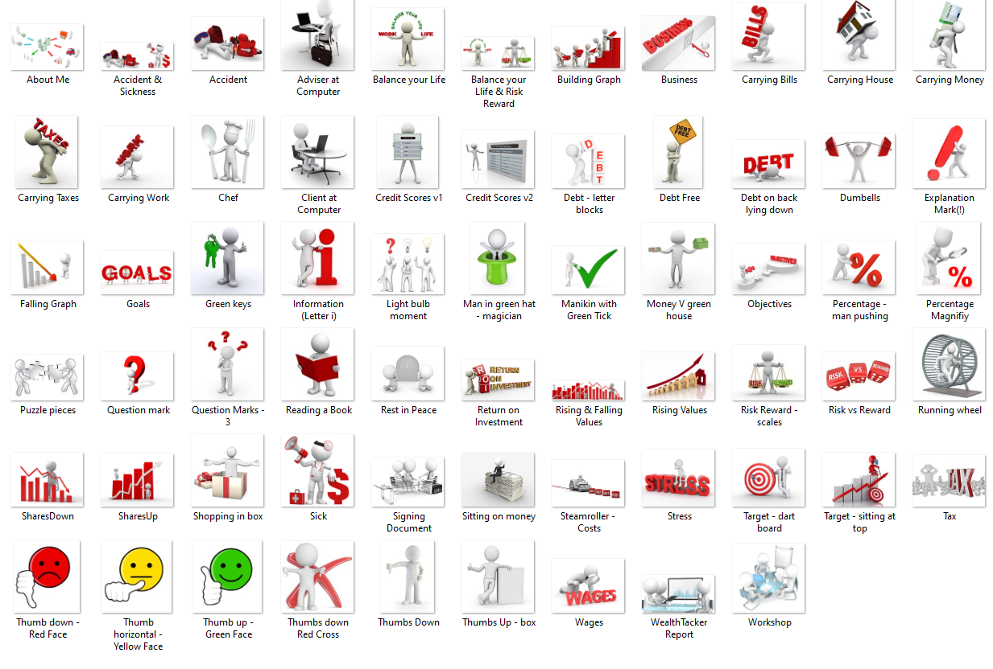

Table of Contents
Advice Online 1
SmartPanels for the Report Builder 1
About Me and My Family 15
About Me: Advice 15
About Me: Employment 15
About Me: Estate Planning 16
About Me: Family 16
About Me: Health 17
About Me: Investment Experience 17
About Me: Objectives 18
About Me: Risk Profile 18
Assets 19
Assets: Bonds 19
Assets: Cash Accounts 20
Assets: Home 20
Assets: Investment Property 21
Assets: Managed Funds 22
Assets: Personal Assets at Start of Plan 22
Assets: Shares 23
Assets: Term Deposits 23
Assets & Liabilities 24
Assets & Liabilities 24
Assets & Liabilities: Assets 26
Assets & Liabilities: Liabilities 26
Bank Cash (Transaction) Account 27
Bank Cash (Transactions) Account – Balance Before and After Transactions 27
Bank Cash (Transactions) Account – Balance Before and After Transactions*** 27
Bank Cash (Transactions) Account – Balance at End of Year 28
Bank Account – Balance at End of Year *** 28
Bank Cash (Transactions) Account: Bank Account – Transactions 28
Budget – Unallocated Funds 29
Budget – Unallocated Funds *** 29
DELETE 29
Cash Flow Summary 30
Cash Flow –––Summary 31
Cash Flow Summary: Expenses 32
Cash Flow Summary: Income 32
Compare Actuals 33
DELETE 33
Compare Actuals – Home 33
DELETE 33
Compare Actuals – Investments 34
DELETE 34
Compare Actuals – Investment Property 35
DELETE 35
Compare Actuals – Managed Investments and Super 36
DELETE 36
Compare Actuals – Net Cash & Interest Earning Accounts 37
DELETE 37
Compare Actuals – Net Investment Properties 38
DELETE 38
Compare Actuals – Net Investments and Super 38
DELETE 38
Compare Actuals – Net Investments 39
DELETE 39
Compare Actuals – Net Shares & Managed Funds 39
DELETE 39
Compare Actuals – Net Worth 40
DELETE 40
Compare Actuals – Net Worth Alt 1 40
DELETE 40
Compare Actuals – Super 41
DELETE 41
Compare Actuals – Total Superannuation 42
DELETE 42
Conversational 43
Conversational: Annuities 44
Conversational: Credit Cards 44
Conversational: Homes 45
Conversational: Interest Earning Accounts 46
Conversational: Insurance 48
Conversational: Investment Properties 49
Conversational: Personal Savings Lifestyle Goals 50
Conversational: Managed Funds 51
Conversational: Pensions from External Sources 52
Conversational: Personal Loans 52
Conversational: Retirement Income 52
Conversational: Salary 53
Conversational: Shares 54
Conversational: Superannuation 55
Conversational: SMSF 56
DELETE 56
Debt Management 57
Debt Management: Loan Balance at Start of Year 57
Debt Management: Loan Payments 57
General 57
General: Average Investment Allocation (5yr) 57
General: Debt Servicing Ratio 58
General: Debt Servicing Ratio *** 58
General: Drawdown Funding (Present Value) 58
General: Financial Performance Snapshot 59
General: Goals (First 5 Years) 59
General: Goals Graph 60
General: Income and Expense Profile 60
General: Insurance Graph 60
General: Key Indicators Snapshot 61
General: Main Strategy 61
General: Milestones 61
General: Plan Comments 61
General: Debt Management 62
NEW PANEL 62
General: Insurance Recommendations 62
NEW PANEL 62
General: Potential Risks 62
NEW PANEL 62
General: My Advice and Limitations of My Advice 62
NEW PANEL 62
General: Plan Cover - Name, Plan Name Ages 62
General: Plan Details 62
General: Plan Objectives 63
General: Plan Risks 64
General: Retirement Income 65
General: Summary at end of Savings and Retirement Phases 65
General: Targets 65
DELETE 65
General: Targets Graphs 66
DELETE 66
General: Targets *** 67
DELETE 67
General: This Report is for User, Plan 67
General: What you owe 68
General: What you own 68
General What you Spend 69
DELETE 69
Loan Report 70
Loan Report: Interest Rates, Capital and Interest Payments 70
Loan Report: Interest Rates, Capital and Interest Payments Graph 70
Loan Report: Loan Balances and Loan Repayment Schedules 71
Loan Report: Personal Budget Expenses (PV) 72
DELETE 72
Loan Report: Personal Budget Expenses Graph (PV) 72
DELETE 72
Loan Report: Planned Management for New Loans and Refinanced Loans 73
Loan Report: Salary Savings 73
Loans 73
Loans: Credit Cards 74
Loans: Current with Lender Details 74
Loans: Home 74
Loans: Investment Property 75
Loans: Personal 75
Loans: Shares 75
Modulators 76
DELETE ALL PANELS ASSOCIATED WITH MODULATORS 76
Modulators: Status 76
DELETE 76
Personal Budget 76
Personal Budget: Expenses Breakdown 76
DELETE 76
Personal Budget: Living Expenses 76
NEW PANEL 76
Personal Budget: Income (Present Value) 77
Progress Report 77
Progress Report: Asset Allocation 77
Progress Report: Asset Allocation and Investment Profile (Retirement) 78
Progress Report: Asset Allocation and Investment Profile (Savings) 78
Progress Report: Assets and Liabilities (FV) (Retirement) 78
Progress Report: Assets and Liabilities (FV) (Savings) 79
Progress Report: Bank Cash (Transactions) Balance 80
Progress Report: Budget Summary (PV) 80
DELETE 80
Progress Report: Investment Profile (Excluding Retirement Accounts) 80
Progress Report: Net Investments & Retirement Funds (FV) 81
Progress Report: Net Investments & Retirement Funds (PV) 81
Progress Report: Net Value of Home 81
Progress Report: Return on Investments (Including Retirement Accounts) 82
Progress Report: Salaries, Drawdown & Pensions from External Sources (Present Values) 82
Progress Report: Statistics (Retirement) 82
Progress Report: Statistics (Savings) 83
Retirement 84
Retirement: Annuities 84
Retirement: Employer Super 85
Retirement: Self-Managed Pension (Superannuation) Fund 87
DELETE 87
Retirement Plan 88
Retirement Plan: Drawdown Allocation 88
Retirement Plan: Drawdown Funding 88
Review 88
Review *** 88
Savings (Investment) Strategy 89
Savings Strategy: Allocation of Savings 89
Savings Strategy: Assets at Start of Year 90
Savings Strategy: Net Assets Graph 90
Savings Strategy: Personal Income & Expenses 90
DELETE 90
Savings Strategy: Real Estate Purchases at Start of Year 91
Savings Strategy: Real Estate Sales at End of Year 91
Savings Strategy – Shares, Managed Funds and Superannuation 91
SMSF 92
DELETE ALL SMSF PANELS 92
Savings Strategy – Statistics & Asset Allocation 92
SMSF: Asset Allocation 92
DELETE 92
SMSF: Asset Allocation (Detailed) 92
DELETE 92
SMSF: Balance at Start of Year 93
DELETE 93
SMSF: Investment Profile 93
DELETE 93
SMSF: Present Values 93
DELETE 93
SMSF: Returns 93
DELETE 93
SMSF: Risk Profile 94
DELETE 94
SMSF: Transactions – Cash 94
DELETE 94
SMSF: Transactions - Investment Property 94
DELETE 94
SMSF: Transactions - Shares and Managed Funds 94
DELETE 94
SOA 95
DELETE ALL PANELS FOR SOA EXCEPT AUTHORITY TO PROCEED 95
SOA: Attitude towards Investing 95
DELETE 95
SOA: Authority to Proceed 95
DO NOT DELETE XXXXXXXXXXXXXX 95
SOA: Commissions 95
DELETE 95
SOA: Commissions Paid on Insurance Policies 96
DELETE 96
Consequences of my advice 96
DELETE 96
SOA: Estate Planning 96
DELETE 96
SOA: Executive Summary 96
DELETE 96
SOA: Fees and Costs 96
DELETE 96
SOA: General Information About Client and Partner 96
DELETE 96
SOA: How to follow my advice 96
DELETE 96
SOA: Improving your Money Management Skills 96
DELETE 96
SOA: Insurance Recommendations 96
DELETE 96
SOA Investment Planning 97
DELETE 97
SOA: List of Attachments 97
DELETE 97
SOA: My Advice 97
DELETE 97
SOA: Product Replacement 97
DELETE 97
SOA: Reasons for my recommendations 97
DELETE 97
SOA: Review of Performance 97
DELETE 97
SOA: Scope of Advice 97
DELETE 97
SOA: Wealth Tracker Summary 97
DELETE 97
SOA: What this document is about 97
DELETE 97
SOA: What you Want 98
DELETE 98
SOA: Custom 1 – 20 98
DELETE 98
Summary Report 98
Summary Report: Asset Allocation 98
Summary Report: Asset Allocation (Detailed) 99
Summary Report: Asset Allocation (Detailed) – Investments 99
Summary Report: Asset Allocation (Detailed) – Retirement Accounts 99
Summary Report – Asset Allocation (Detailed) $ Values 99
Summary Report – Asset Allocation (Detailed) $ Values – Investments 100
Summary Report – Asset Allocation (Detailed) $ Values – Retirement Accounts 100
Summary Report – Asset Allocation (Detailed) $ Values (5yr) 100
Summary Report – Asset Allocation (Detailed) $ Values (5yr) – Investments 100
Summary Report – Asset Allocation (Detailed) $ Values – (5yr) Retirement Accounts 101
Summary Report: Assets 101
Summary Report: Debt Servicing Ratio 101
Summary: Investment Profile 101
Summary: Investment Profile (Investments) 101
Summary: Investment Profile (Retirement Accounts) 102
Summary Report: Investment Income 102
Summary Report: Liabilities 102
Summary Report: Net Value of All Investments 102
Summary Report: Pensions (External Sources) 102
Summary Report: Retirement Accounts Net Value 103
Summary Report – Risk Profile 103
Summary Report – Risk Profile – Investments 103
Summary Report – Risk Profile – Retirement Accounts 103
Super 104
Super Asset Allocation 104
Super: Balance of Fund 104
Super: Fees and Taxes 105
Super Investment Profile 105
Super: Risk Profile 105
Super: Present Values 105
Super: Transactions 105
Tax Estimator 106
Tax Estimator: - Estimated Tax Due 106
Tax Estimator: Income and Capital Gains to be Taxed 107
Image Library 108
About our Image Library 108
Full List 108
Images 109
About Me 109
Accident and Sickness 109
Accident 109
Adviser at Computer 109
Balance your Life 110
Balance your Life & Risk Reward – Scales 110
 110
Building Graph 110
Business 110
Carrying Bills 111
Carrying House 111
Carrying Money 111
Carrying Taxes 112
Carrying Work 112
Chef 112
Client at Computer 113
Credit Score v1 113
Credit Score v2 113
Debt – letter blocks 114
Debt Free 114
Debt on back lying down 114
Dumbbells 115
Explanation Mark (!) 115
Falling Graph 115
Goals 116
Green Keys 116
Information (Letter i) 116
Light bulb moment 117
Man in green hat - magician 117
Manikin with Green Tick 117
Money V green house 118
Percentage – man pushing 118
Percentage - magnify 119
Puzzle Pieces 119
Objectives 120
Question Mark 120
Question marks - 3 120
Reading a Book 121
Rest in Peace 121
Return on Investment 121
Rising & Falling Values 121
Rising Values 122
Risk Reward - scales 122
Risk Vs Reward 122
Running wheel 123
Shares Down 123
Shares Up 123
Shopping in box 124
Sick 124
Signing Document 124
Sitting on Money 125
Steamroller -Costs 125
Stress 125
Target – dart board 126
Target – sitting on top 126
Tax 126
Thumb down – Red Face 126
Thumb horizonatal – Yellow Face 127
Thumb Up – Green Face 127
Thumbs Down – Red Cross 127
Thumbs Down 127
Thumbs Up - box 128
Wages 128
Wealth Tracker Report 128
Workshop 129
Excel and Data Tables 130

About Me and My Family

Notes xxx
You will need to create one new panel after Your Objectives for the first 5-years.
- Your objectives after the first 5-years

About Me: Advice
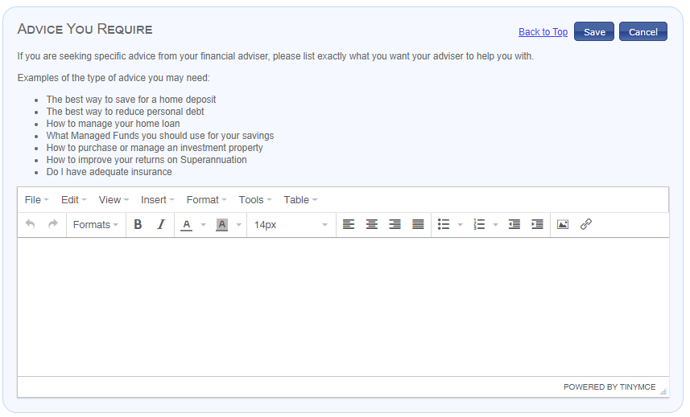

About Me: Employment
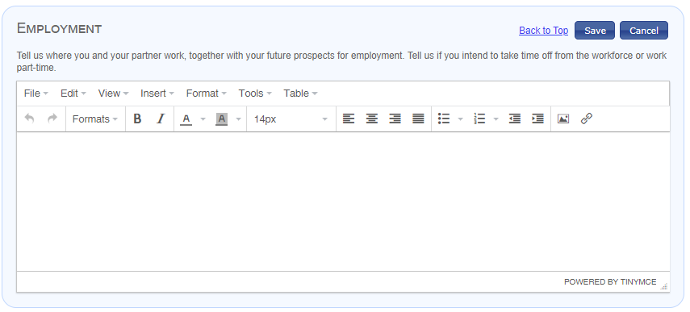

About Me: Estate Planning
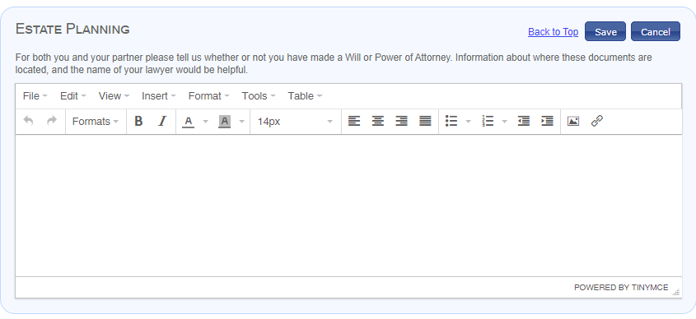

About Me: Family
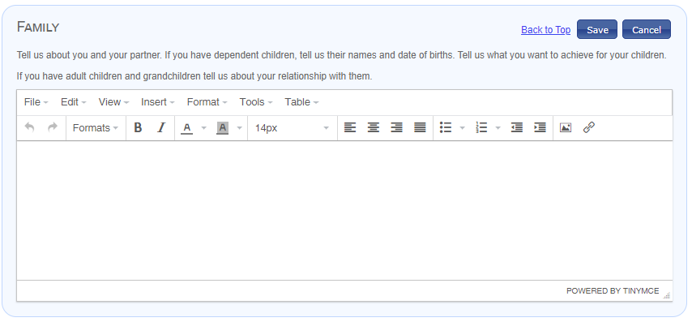

About Me: Health
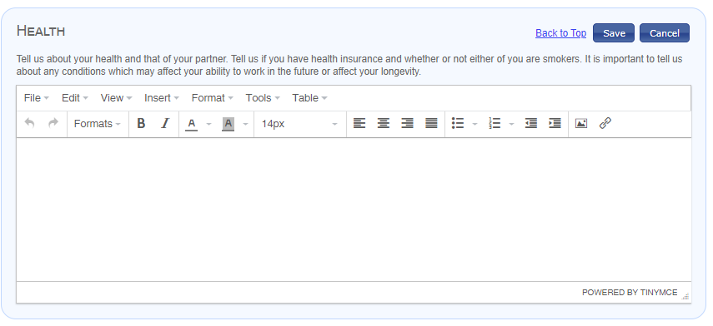

About Me: Investment Experience
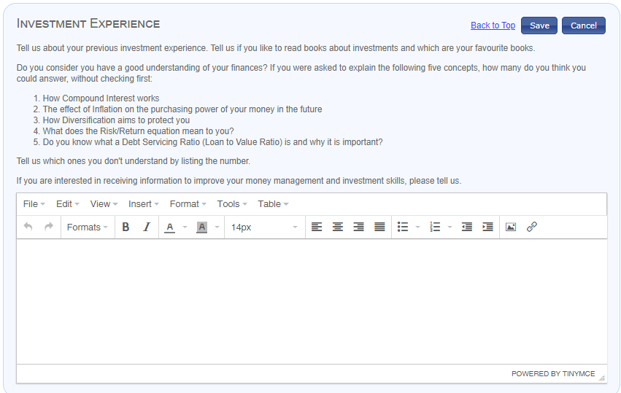

About Me: Objectives
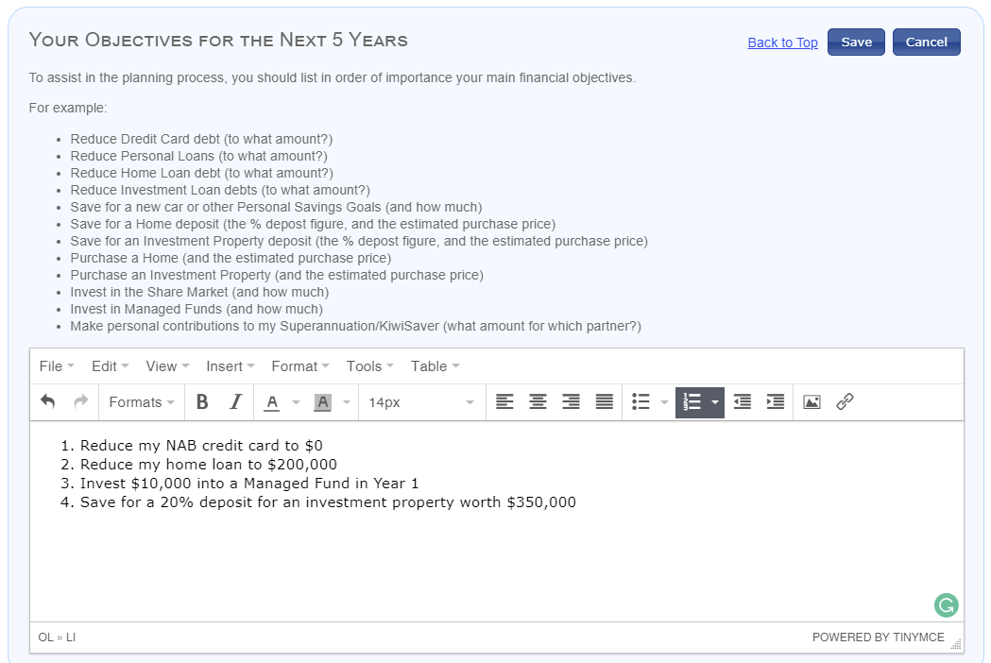

About Me: Objectives after First 5-Years

NEW

About Me: Risk Profile
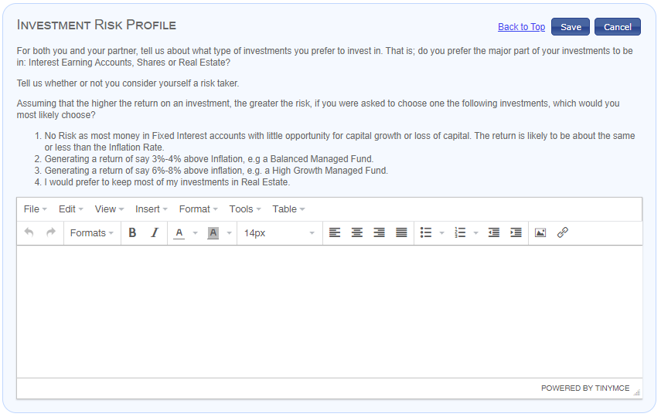

Assets
Notes:

There are a set of graphs which are displayed for each asset account within an asset type.

If you want to show all these graphs in a report If the asset type is not part of a plan for which a report is generated, the panel is not displayed on that report.

The name of each Asset Account appears at the top left corner (Heading 2) of the SmartPanel. If a plan has more than one account in any asset type, all accounts in that plan are listed and identified by their name.

Assets: Cash Accounts
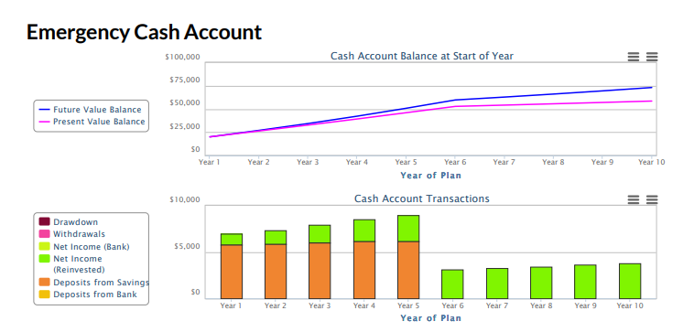

Assets: Home
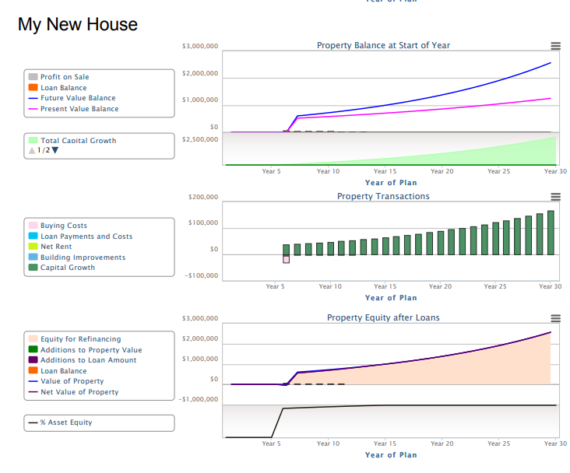

Assets: Investment Property
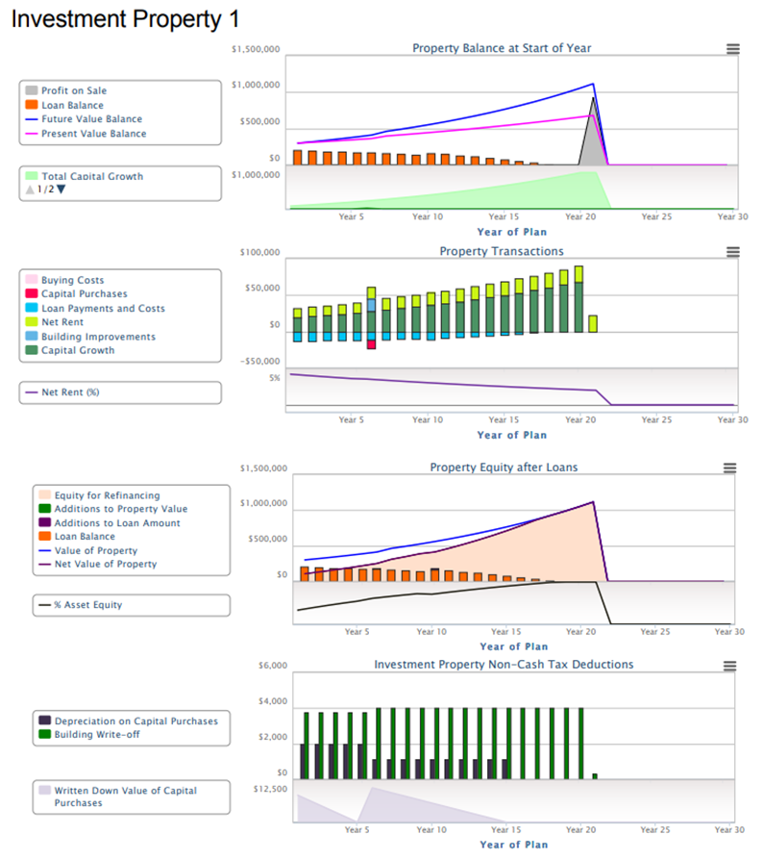

Assets: Managed Funds & Shares

AMEND
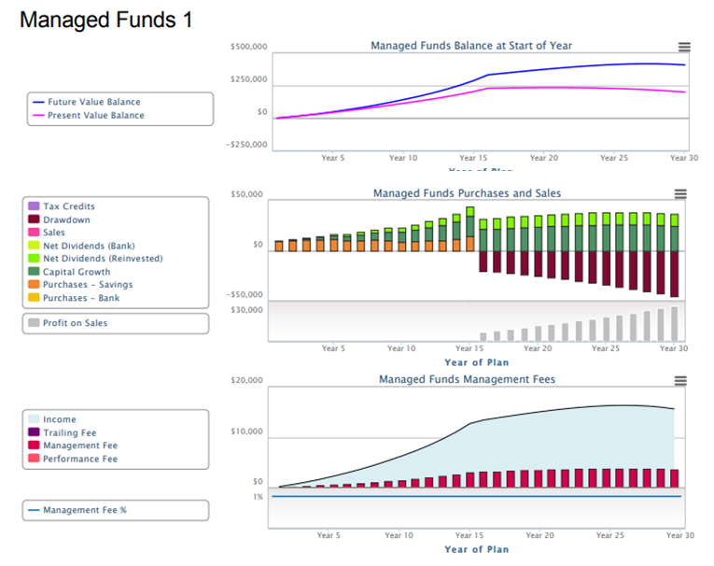

Assets: Personal Assets at Start of Plan
These are only listed in the Starting Position where detailed Assets and Liabilities at Start of Plan are displayed.



Assets & Liabilities

Notes:
These SmartPanels are generated from the Assets & Liabilities page found on the Reports chevron. These panels have been designed to give you maximum flexibility.

Panels may be for

- Assets & Liabilities (Complete overview including Net Asset Value & recommended)
- Assets & Liabilities: Assets Only
- Assets & Liabilities: Liabilities Only

Once the panel has been selected you have three selections:

- Indexing Method
  - Future Value
  - Present Value
- Plan Phase
  - Default Phase (The first phase of the plan whether Savings or Retirement)
  - Savings Phase
  - Retirement Phase
- Year Range
  - Years 1 – 5
  - Years 6 - 10

Here is a selection of examples:

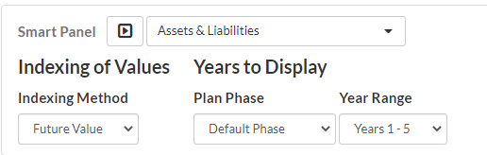

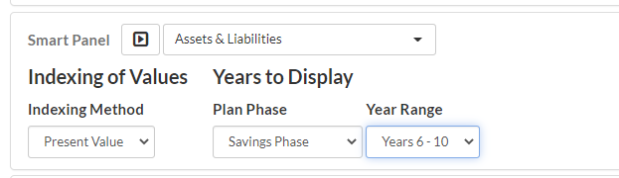

Assets & Liabilities
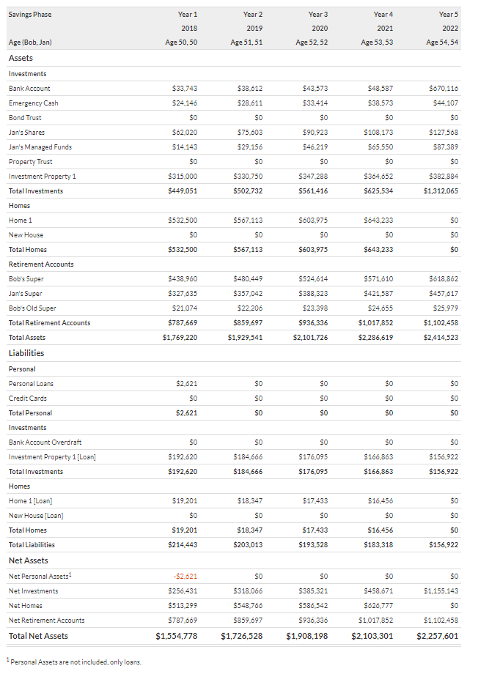

Assets & Liabilities: Assets
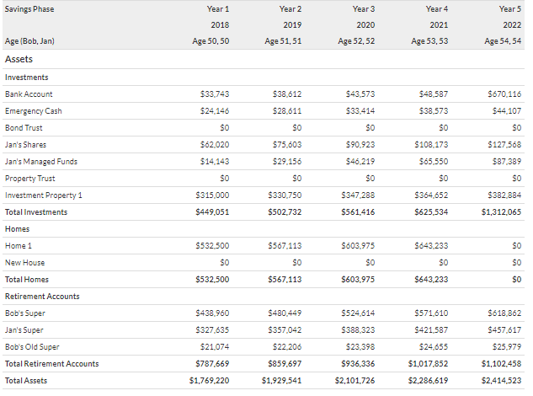

Assets & Liabilities: Liabilities
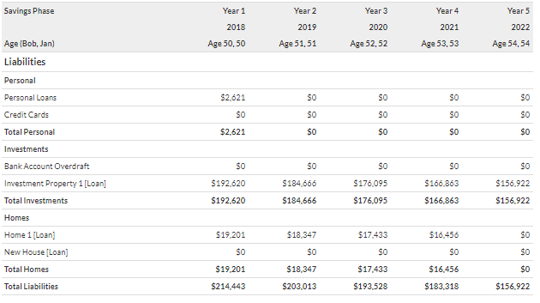

Bank Account
This is the account through which all transactions of the plan are processed. Monitoring the balance of this account is very important. If the account is overdrawn, and no overdraft limit has been listed, the plan is purchasing assets with money it does not have which means it is unsustainable and not a workable plan.

Bank – Balance Before and After Transactions

The Program displays the Balance of the account BEFORE and AFTER any transactions any transactions deemed to occur at the Start of Year. For example, a deposit for a property purchase would be withdrawn at the start of the year.

Note the image panel is only displayed if the account is overdrawn by more than the nominated Overdraft Limit.

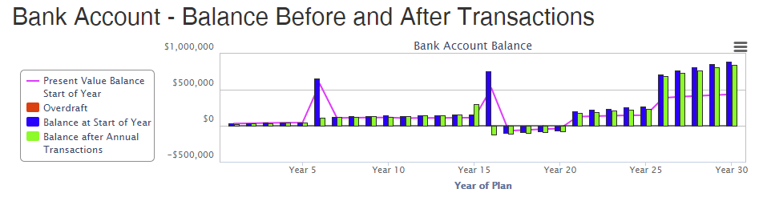

Bank Account – Balance Before and After Transactions***

Bank Account – Balance at End of Year
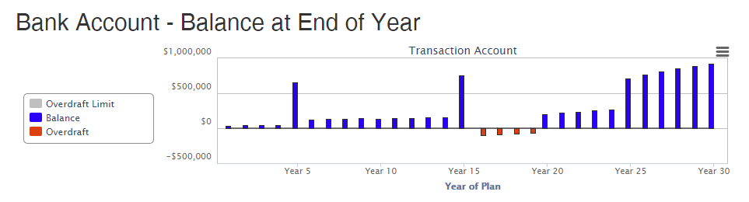

Bank Account – Balance at End of Year ***
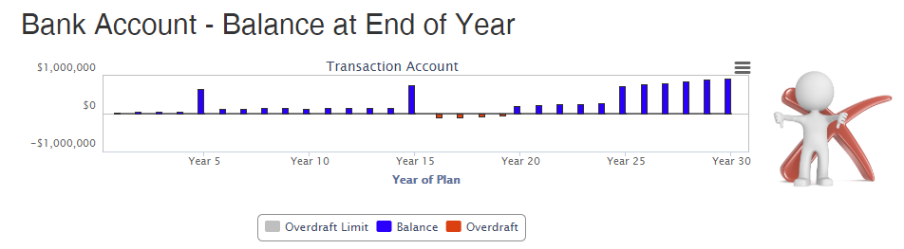

Bank Account: Bank Account – Transactions
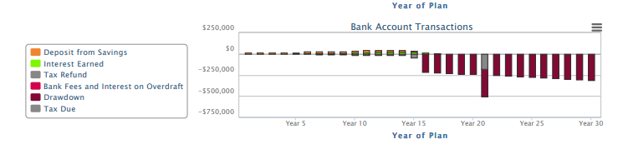

Notes:

This graph only shows the transactions relevant to the Account. It does not include all the yearly transactions for buying and selling assets or loan costs.

Cash Flow Summary
These SmartPanels are generated from the Cash Flow Summary page found on the Reports chevron. These panels have been designed to give you maximum flexibility.

Panels may be for

- Cash Flow Summary (Complete overview & recommended)
- Cash Flow Summary: Income Only
- Cash Flow Summary: Expenses

Once the panel has been selected you have three selections:

- Indexing Method
  - Future Value
  - Present Value
- Plan Phase
  - Default Phase (The first phase of the plan whether Savings or Retirement)
  - Savings Phase
  - Retirement Phase
- Year Range
  - Years 1 – 5
  - Years 6 - 10

Here is a selection of examples:

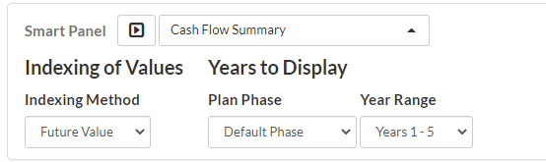

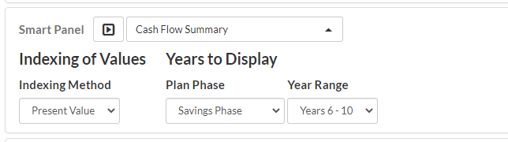

Cash Flow –––Summary

AMEND NAMES
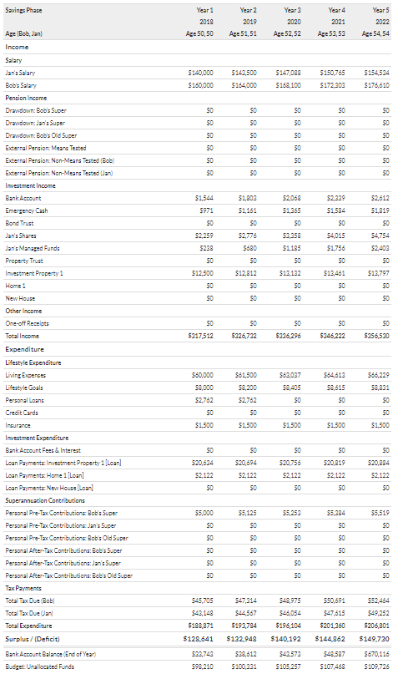

Cash Flow Summary: Expenses

AMEND NAMES
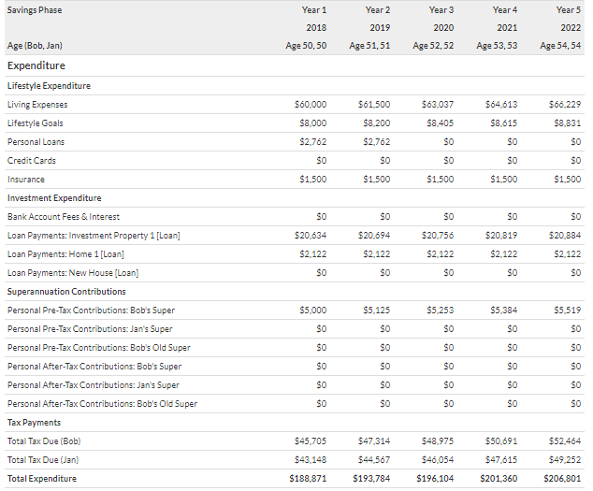

Cash Flow Summary: Income
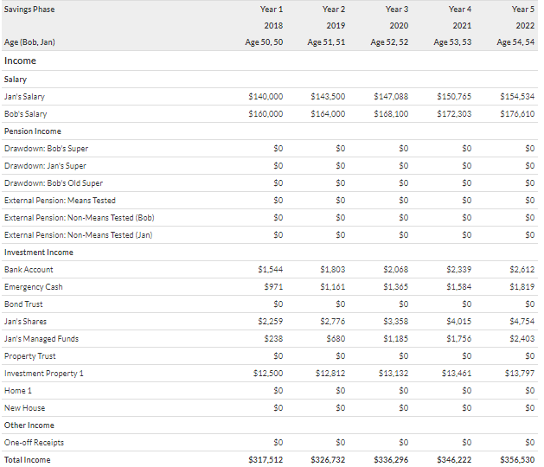

Conversational

Conversational SmartPanels are designed to automatically draw out all the information about a specific account and present that information in an easy-to-read format so that everything regarding all the assets (or other information) are presented.

All the SmartPanels are included in the Report, Plan Map. This report is available on the chevron Reports and is available for all.

In addition, a Template Report called Plan Map Illustrated is included for use in the Client Review or for Connect Clients – Plan Review. It is the same report, but includes the Conversational SmartPanels on the left and the graphs associated with the account on the right. This allows the quick generation of the report for meetings and this information can be shared with the client after the meeting. No advice is included in the report.

This is a fully automated report which also includes the information on the Outline Chevron.

Conversational: Credit Cards
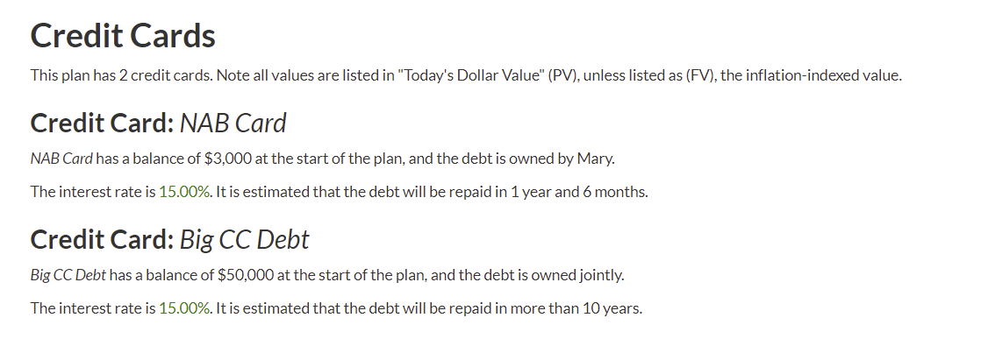

Conversational: Homes
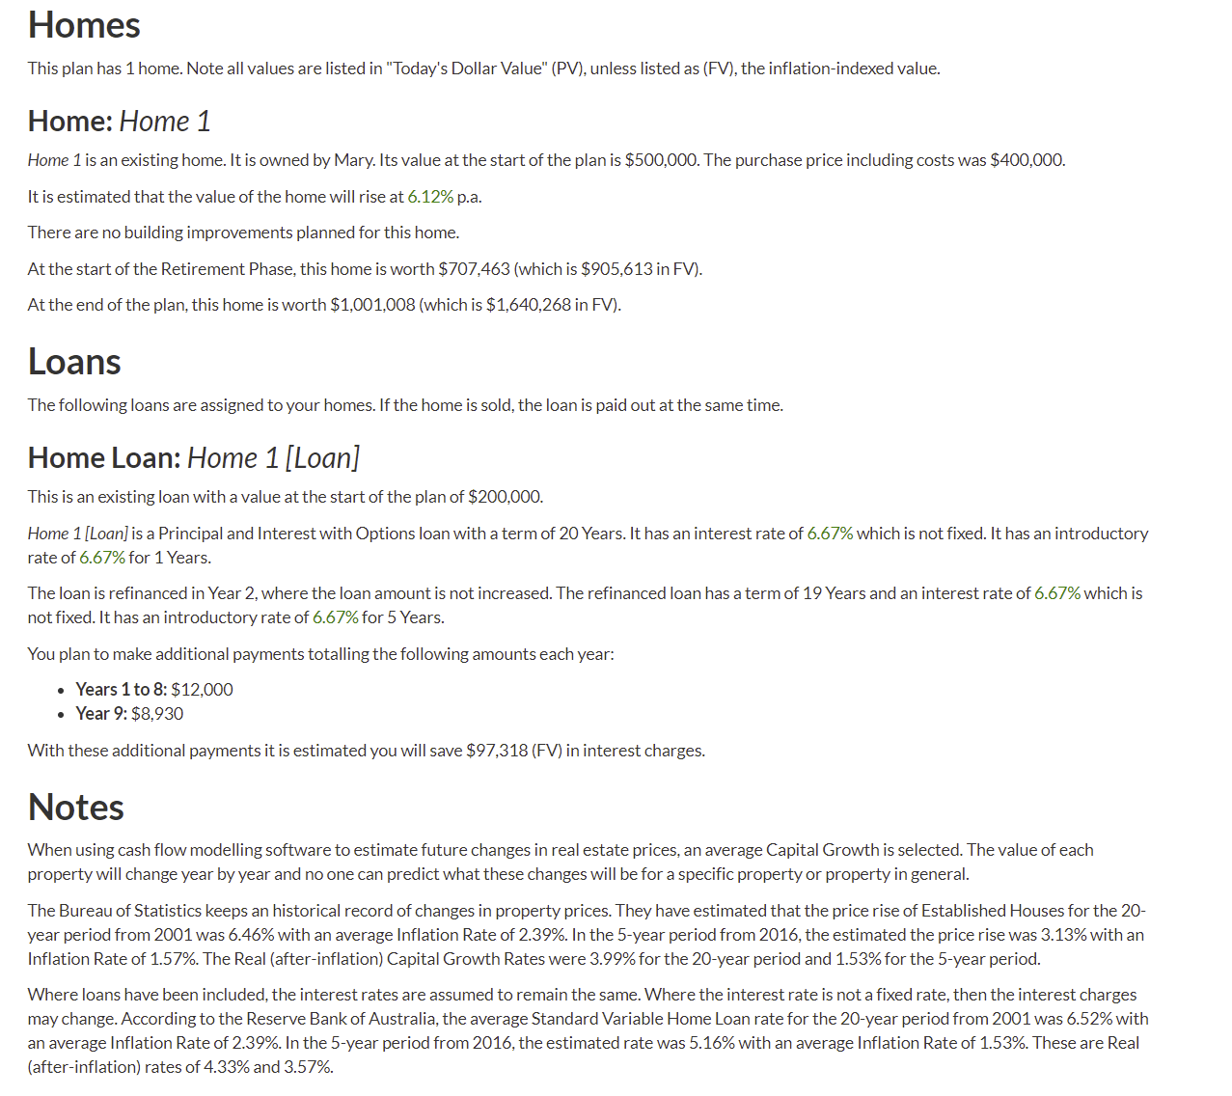

Conversational: Interest Earning Accounts

AMEND
Note: xxx Name change for Bank).
This SmartPanel will always include the Bank Account and then add any other Interest Earning Accounts in the Plan – Cash, There will be no TDs and Bonds.

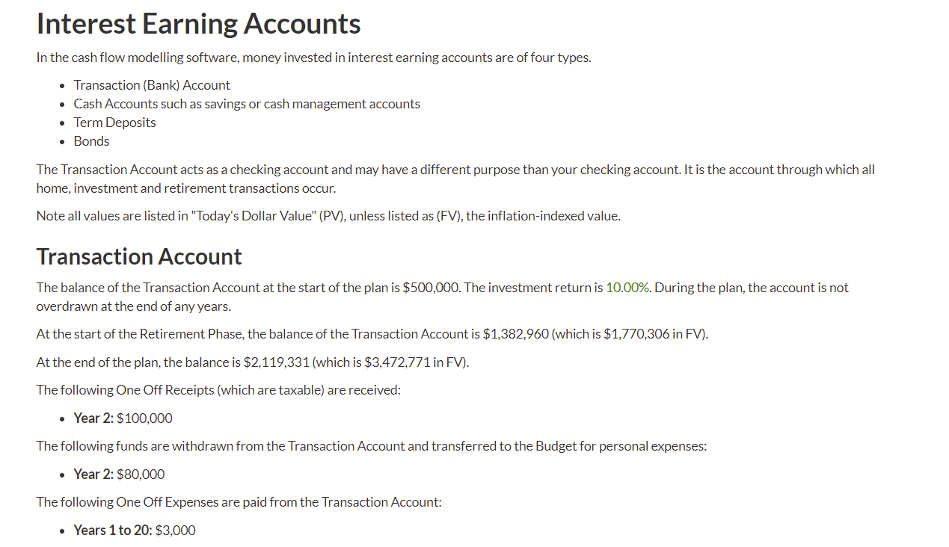
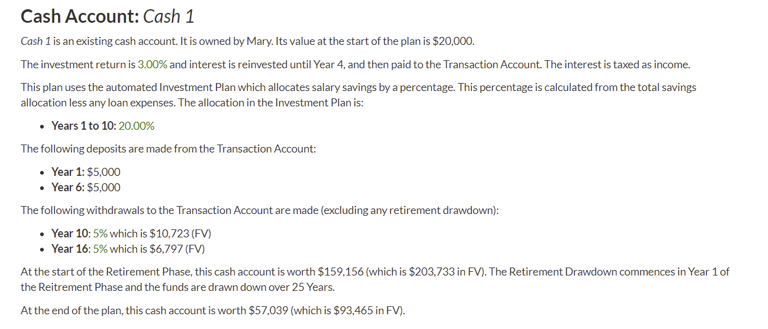
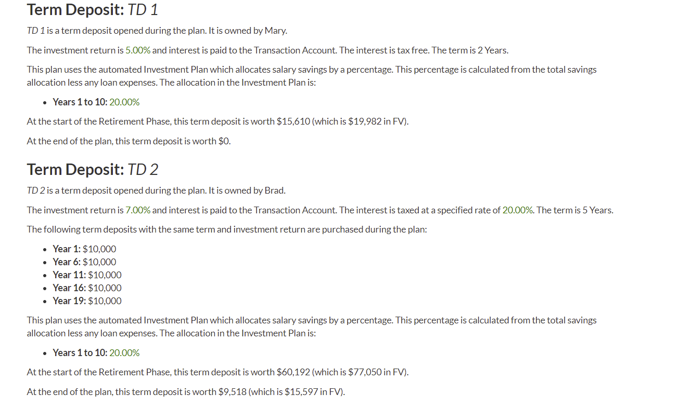
e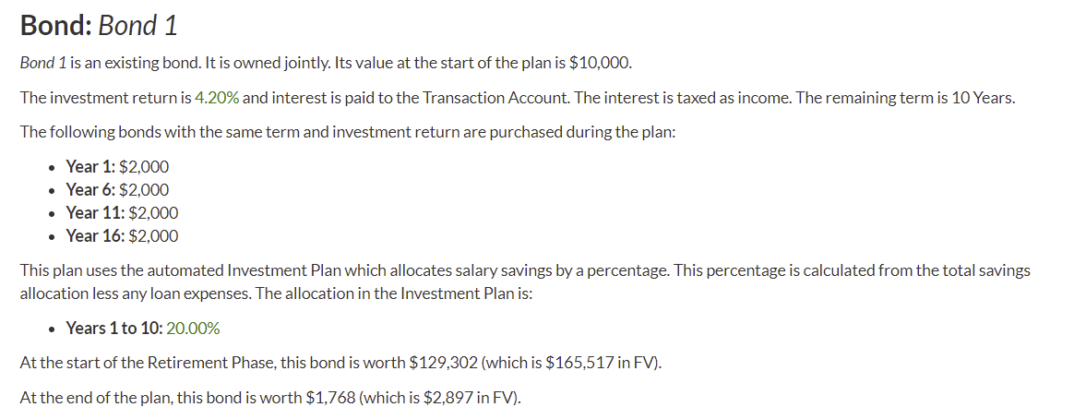

Conversational: Insurance
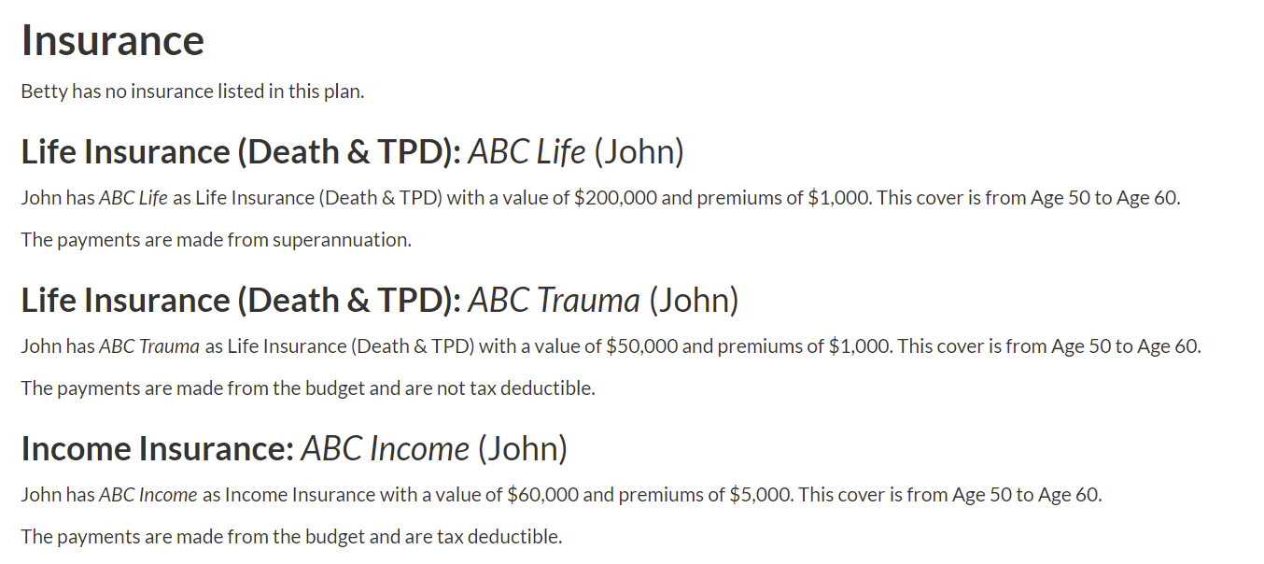

Conversational: Investment Properties
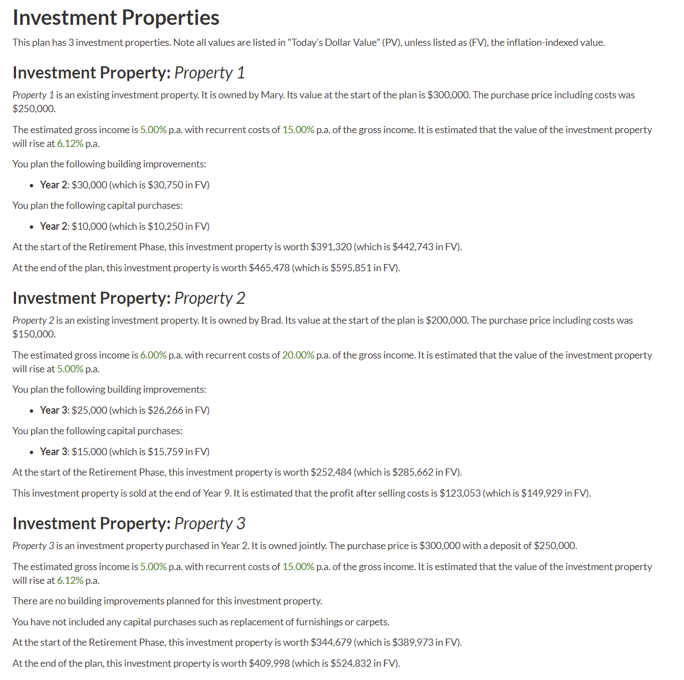
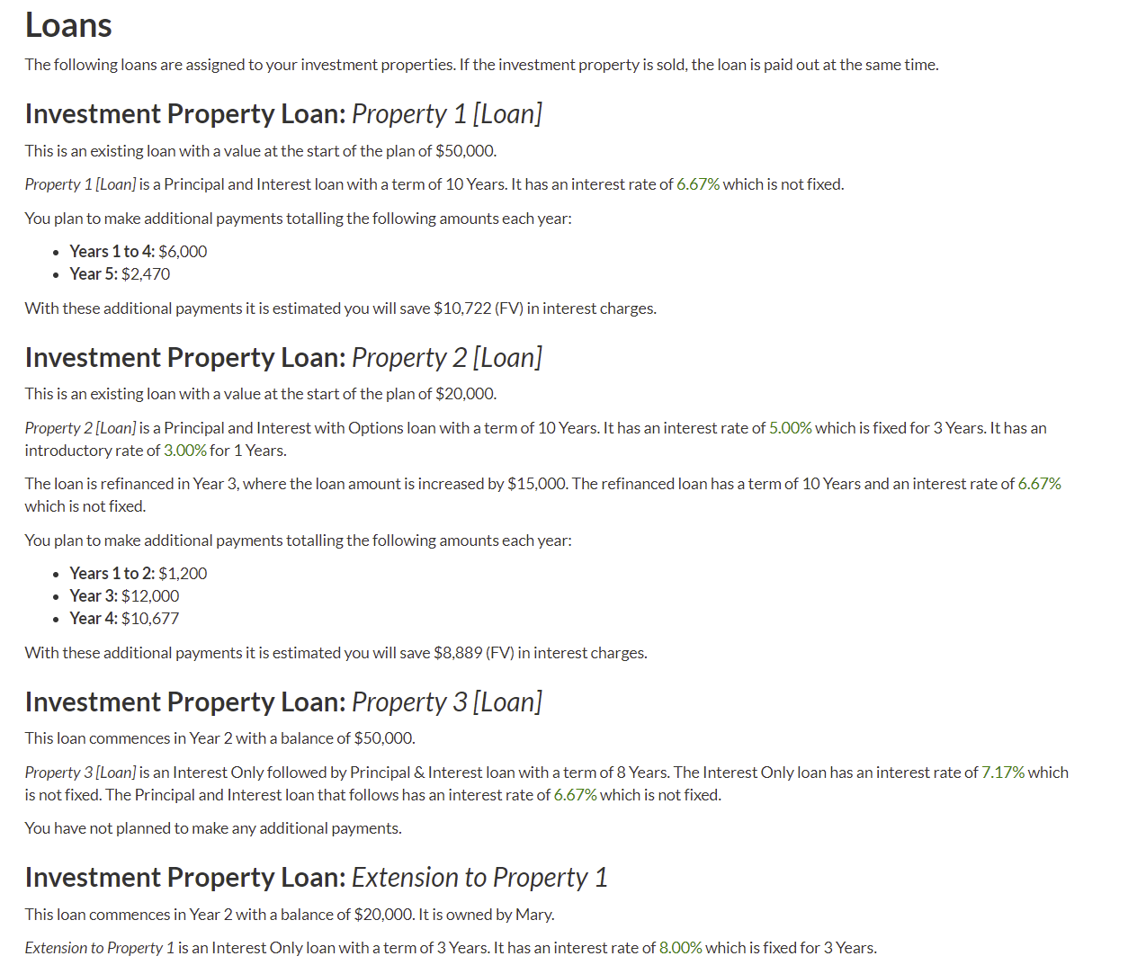
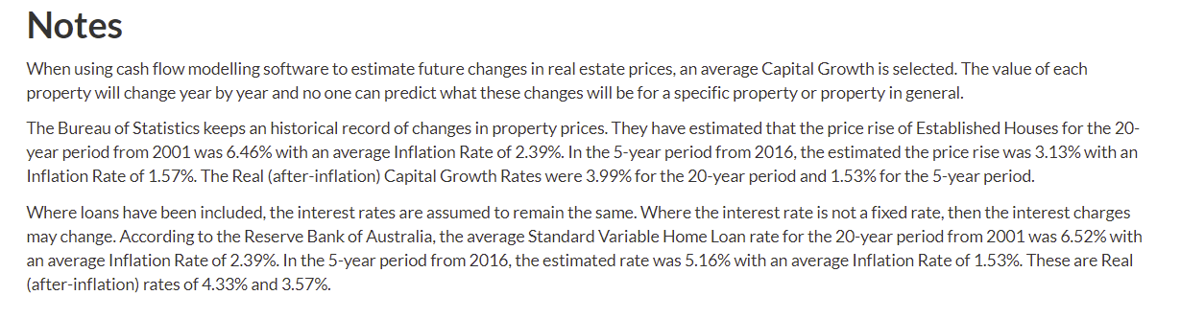

Conversational: Personal Savings Lifestyle Goals

AMEND

Notes: xxx Name change of panel to Personal Savings
Use the heading Personal Savings and then Replace Lifestyle Goals with Savings for each item listed
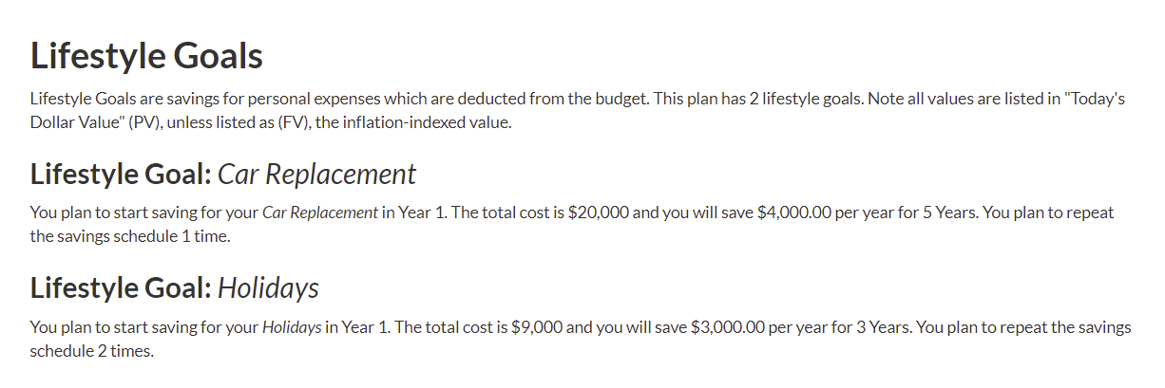

Conversational: Managed Funds & Shares

AMEND

Includes Shares
Only the details of the first Managed Fund is included in this example
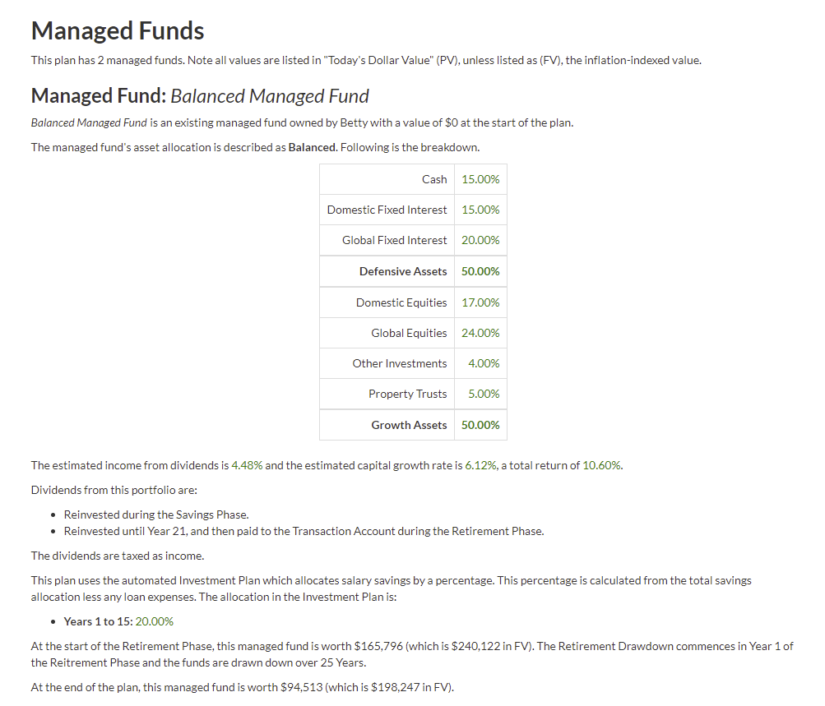

Conversational: Pensions from External Sources
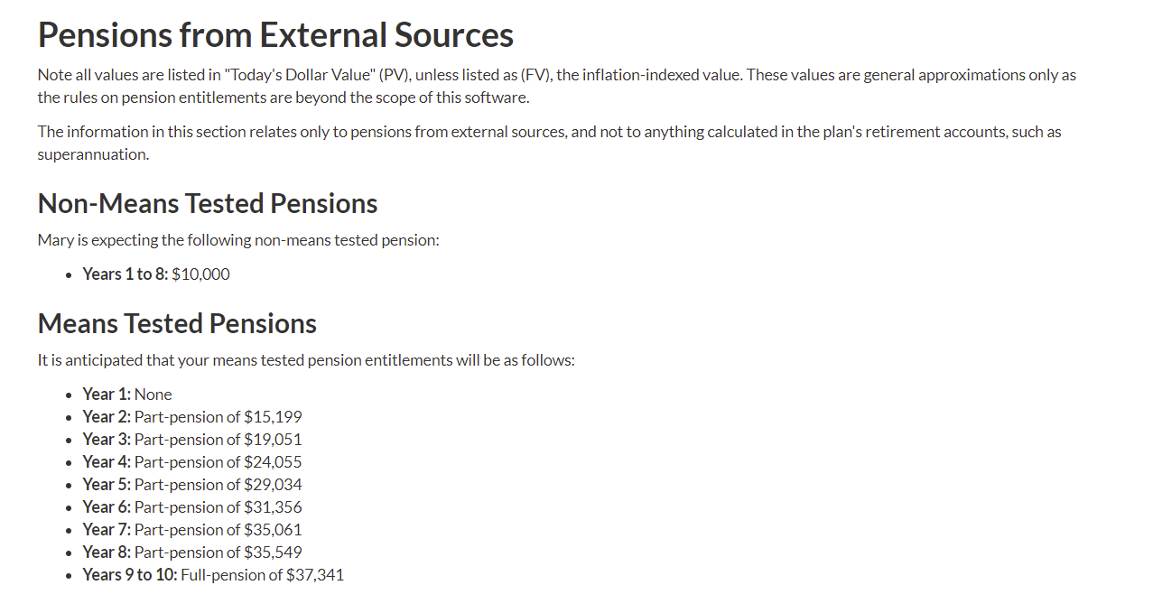

Conversational: Personal Loans
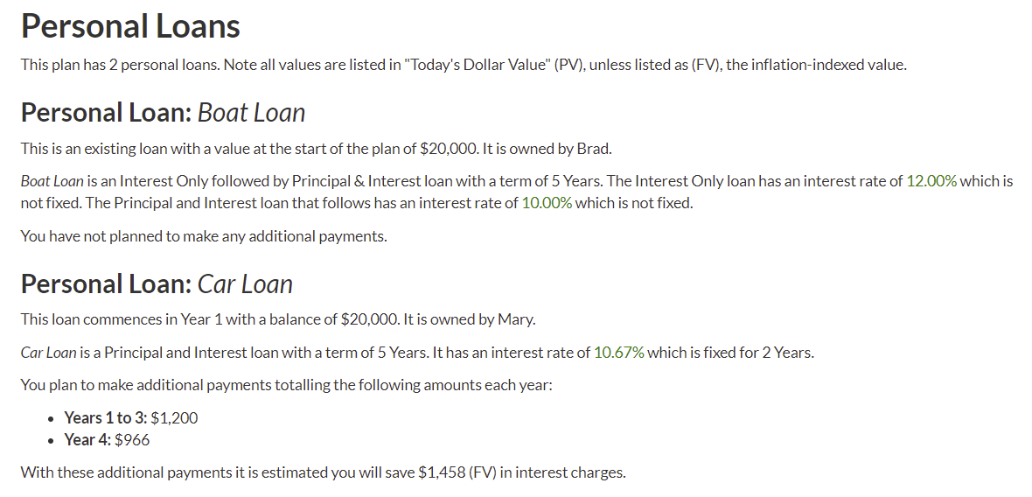

Conversational: Retirement Income
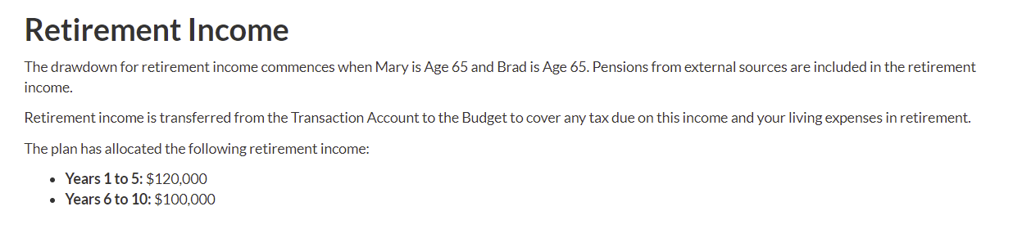

Conversational: Salary
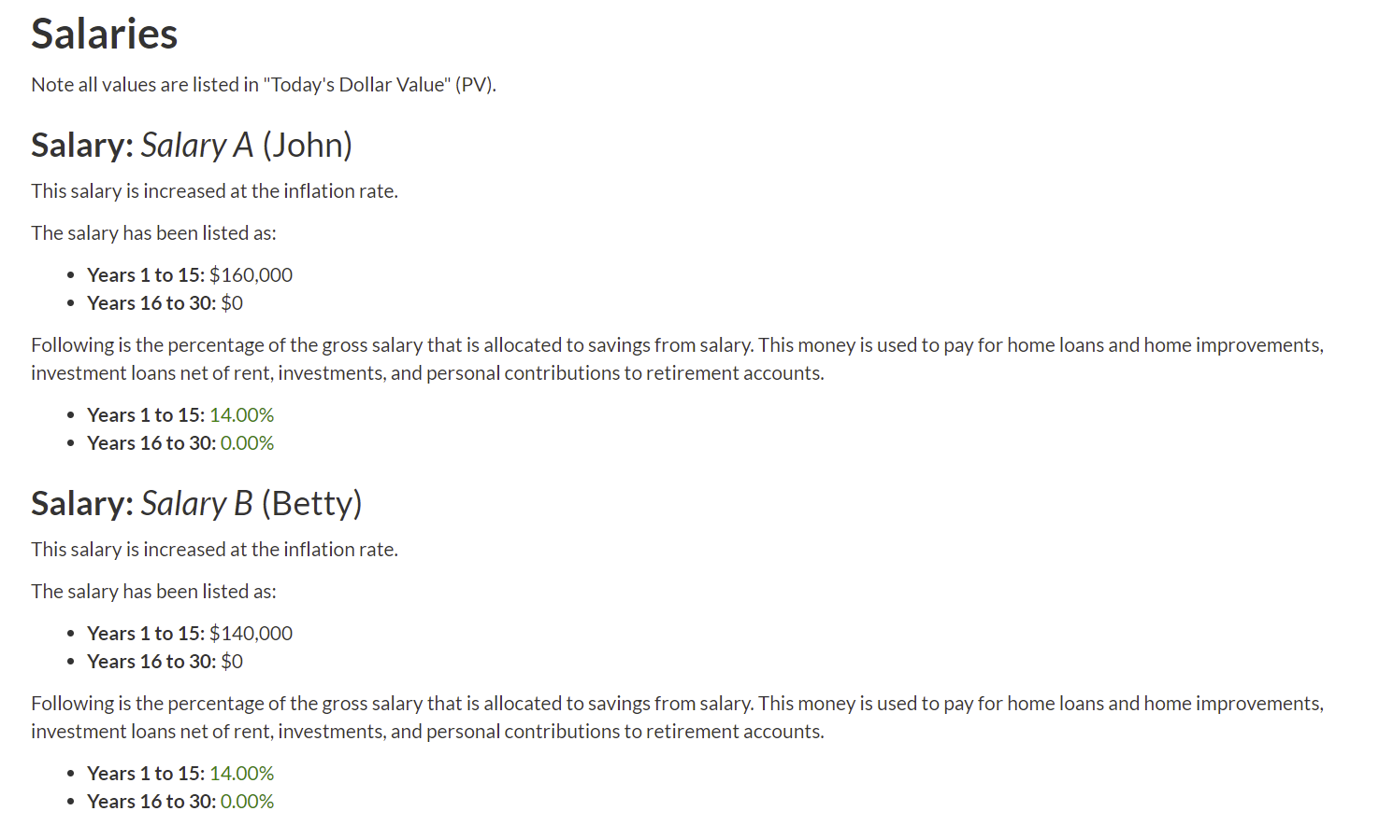

Conversational: Superannuation
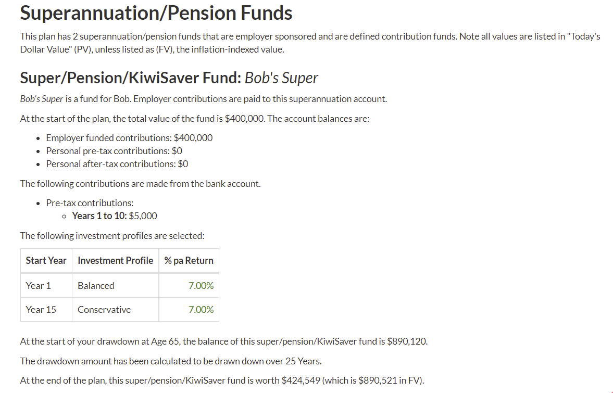

Debt Management

Debt Management: Loan Balance at Start of Year
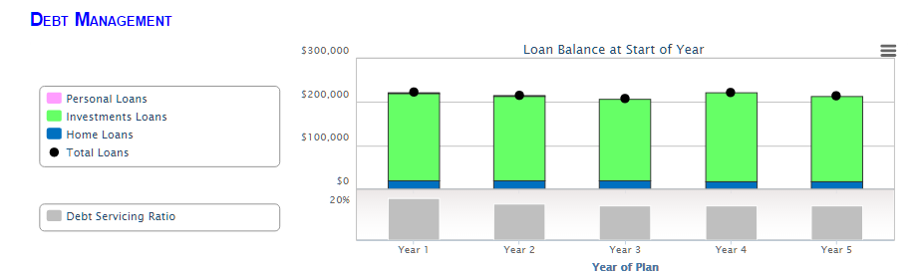

Debt Management: Loan Payments
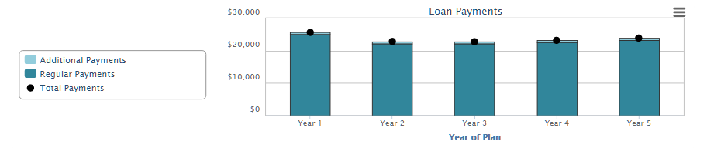

General

General: Debt Servicing Ratio
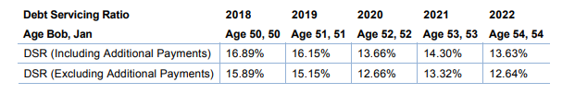

General: Debt Servicing Ratio ***

General: Drawdown Funding (Present Value)
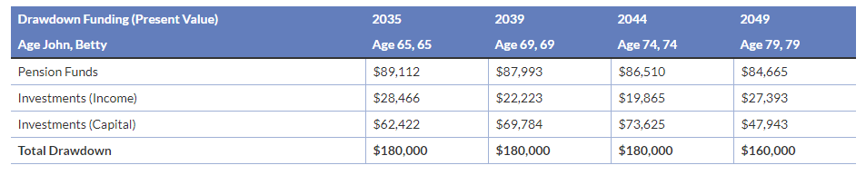

General: Lifestyle Goals (Personal Savings)

AMEND

Notes: xxx Name change from Lifestyle Goals to Personal Savings

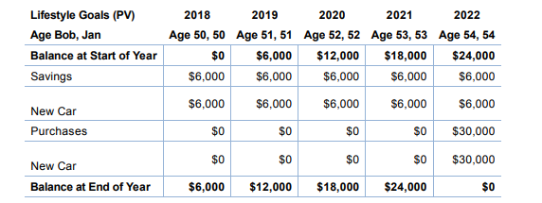

General: Goals Graph

AMEND

Notes: xxx Name change form Lifestyle Goals to Personal Savings.
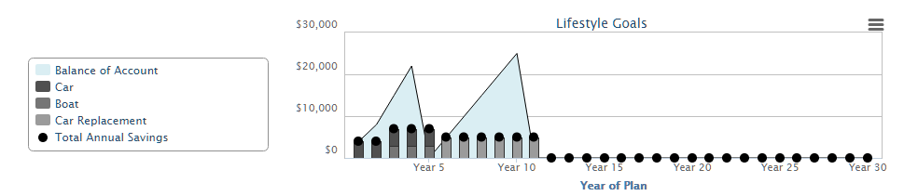

General: Insurance Graph
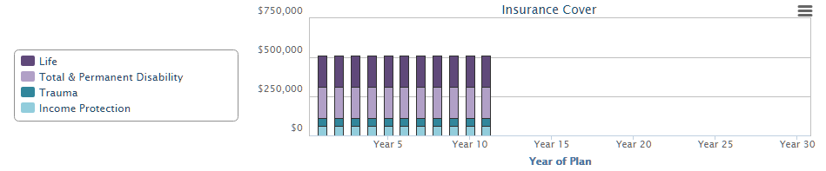

General: Main Strategy

Notes:

If no information has been written, the heading or the SmartPanel does not display.



General: Milestones

AMEND

Note: xxx Change name to Milestones (Financial Goals & Life Events)
Note it has not been decided if these should be split or kept in the one panel


General: Plan Comments

Notes:

If no information has been written, the heading or the panel does not display)

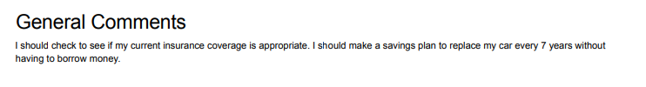

General: Debt Management

NEW PANEL

This will be one of the new panels on the chevron Outline.

General: Insurance Recommendations

NEW PANEL
This will be one of the new panels on the chevron Outline.

General: Potential Risks

NEW PANEL
This will be one of the new panels on the chevron Outline,

General: My Advice and Limitations of My Advice

NEW PANEL
This will be one of the new panels on the chevron Outline.

General: Plan Objectives

Notes:

If no information has been written, the heading or the panel does not display)

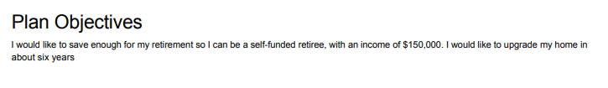

General: Plan Risks

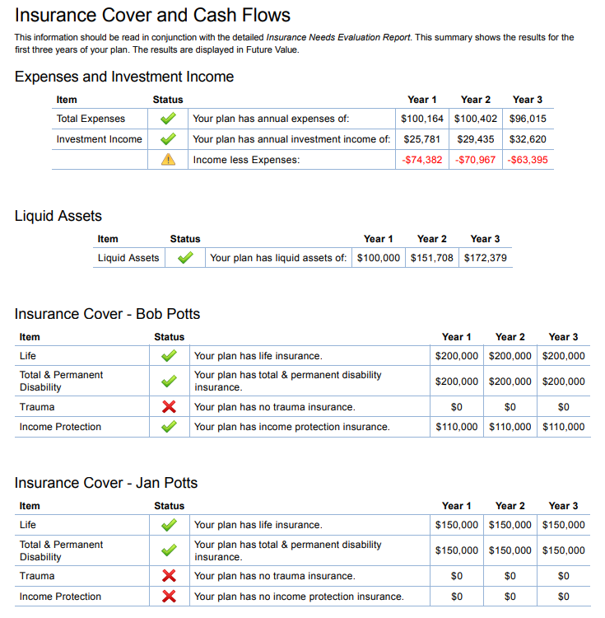

General: Retirement Income
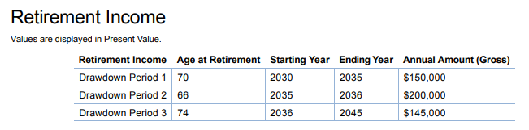

General: Summary at end of Savings and Retirement Phases
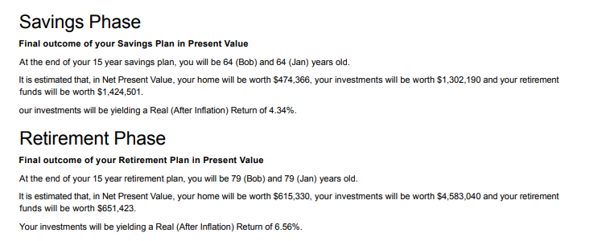

General: What you owe
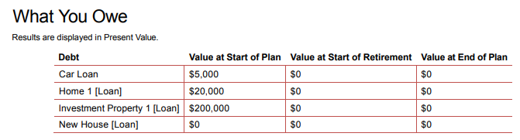

General: What you own

AMEND

Notes: Name change for Transaction Account to Cash (Transactions)

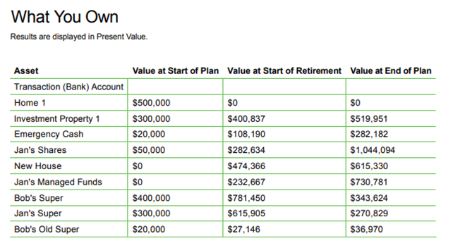

Loan Report

Notes:

These are panels from the 5-year Loan Report (Debt Management Report is the same). It does not include the information for Interest Rate Risk Assessment and Reducing Debt Levels, as these are coded to change according to the information added to that report – Interest Rate Increase and Optional Expense Percent. The panel for Lender Details has also been added.

Loan Report: Interest Rates, Capital and Interest Payments
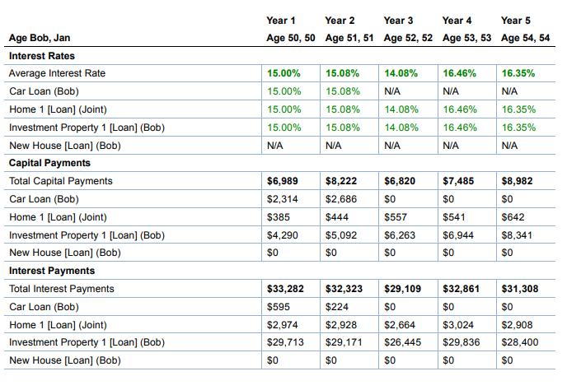

Loan Report: Interest Rates, Capital and Interest Payments Graph
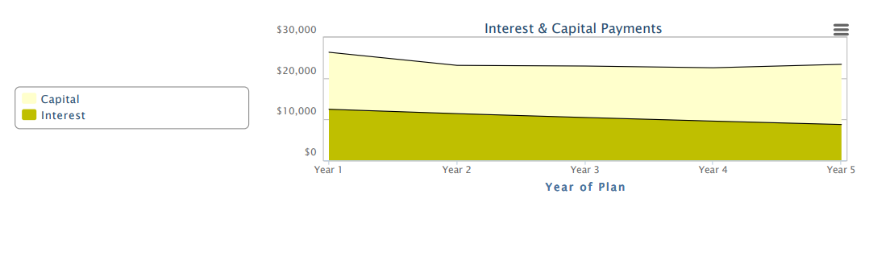

Loan Report: Loan Balances and Loan Repayment Schedules
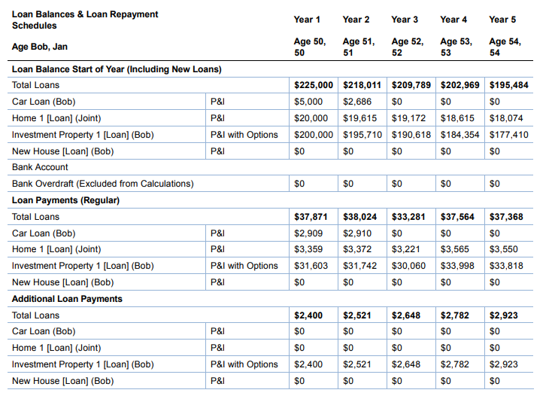

Loan Report: Planned Management for New Loans and Refinanced Loans
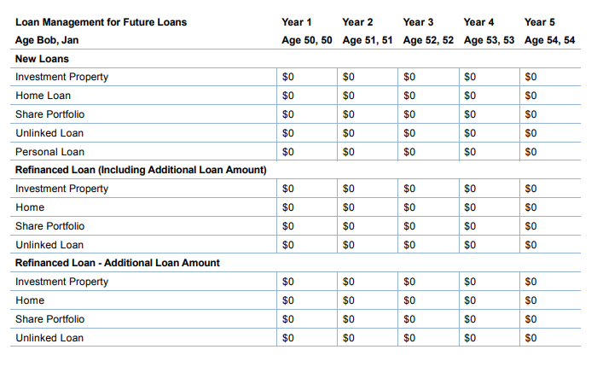

Loan Report: Salary Savings
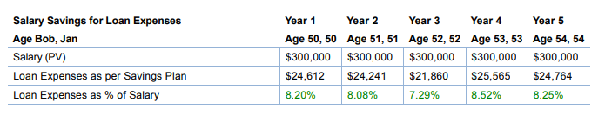

Loans

Notes:

For each Loan Account, the Name of the Loan is listed in the top left hand corner.

Loans: Credit Cards
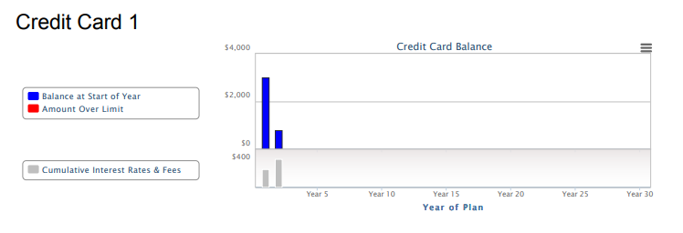

Loans: Current with Lender Details
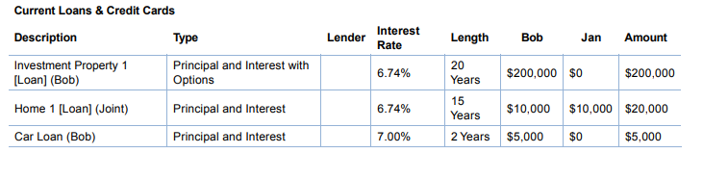

Loans: Home

Notes:

Graphs may be different depending on whether it is an Interest Only or P&I Loan or combined loan. (No additional payments can be made on Interest only loans. Same for Investment Property graphs

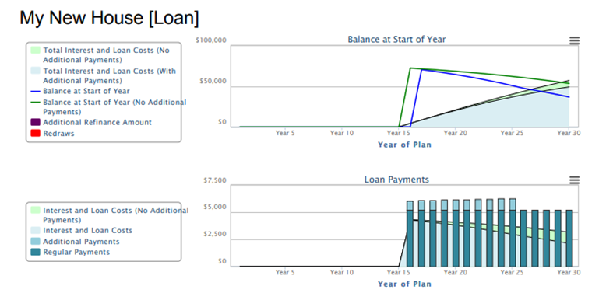

Loans: Investment Property
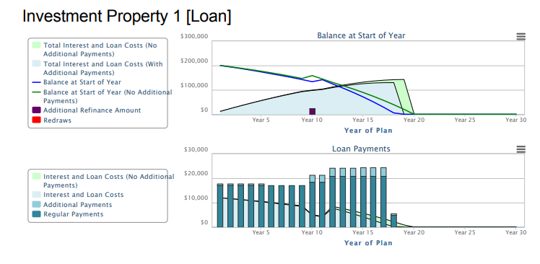

Loans: Personal
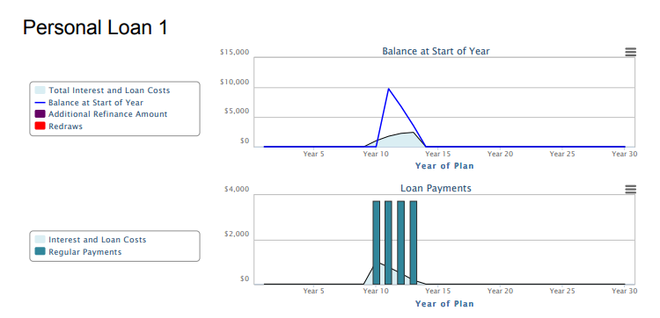

Loans: Shares
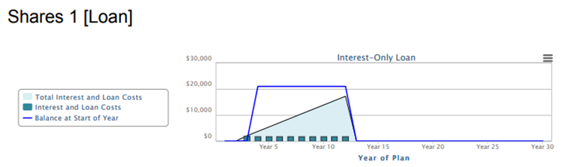

NEW PANEL
Show a graph of Living Expenses (PV)

Personal Budget: Income (Present Value)
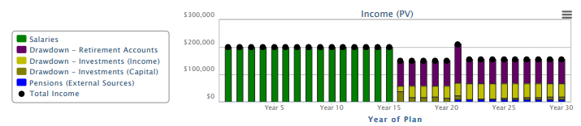

Progress Report

Notes:

These panels are based on the report currently called Plan Summary. Previously it was called Progress Report and hence the name. In the Plan Summary, the first part is divided into information for the Savings and the Retirement Phase. If you are creating a Report, which is only a Savings or Retirement Plan, then you would only include the panels for the type of plan. In a Lifetime Plan you would need to include both.

I would suggest that you make a report for a Lifetime Plan, including both sets of panels and then make two copies of this Report and adjust each so you have a Savings Plan and Retirement Plan. That way you will have one Report, but 3-versions depending on the Plan Type.

At the end of the plan are 8 graphs which give a good overview of the plan. The other information shows the data for the start of the plan, then the values for the End of Year 1, Last year of Phase and 2 intervening periods. The intervening periods will vary, depending on the length of the plan.

Progress Report: Asset Allocation
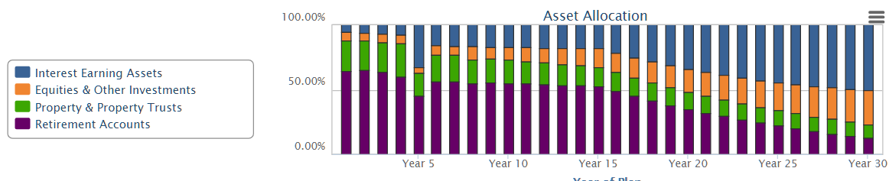

Note: The SmartPanel Summary: Asset Allocation has two graphs. One for Value of Asset and one for Income. This is to identify there an annuity has $0, value, but an income stream.

Progress Report: Asset Allocation and Investment Profile (Retirement)

AMEND

Name changes
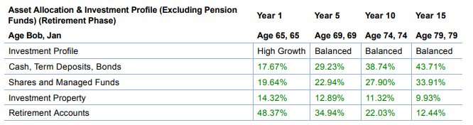

Progress Report: Asset Allocation and Investment Profile (Savings)

AMEND

Name changes
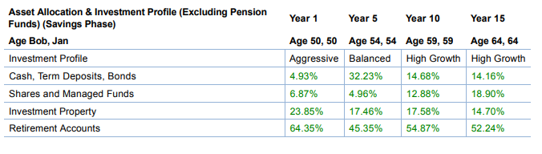

Progress Report: Assets and Liabilities (FV) (Retirement)
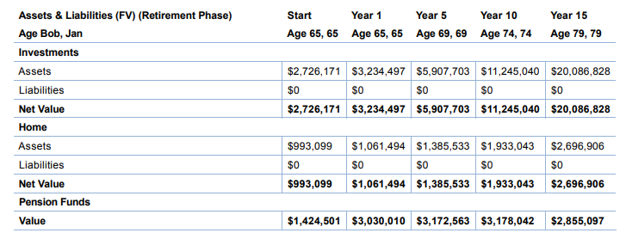

Progress Report: Assets and Liabilities (FV) (Savings)
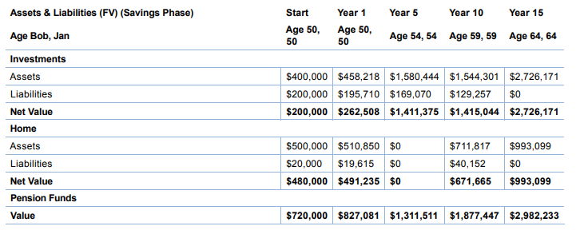

Progress Report: Bank Balance

Notes:

This is a really good graph to include as it ensures the Cash (Transactions) Account is not overdrawn beyond the Overdraft Limit.

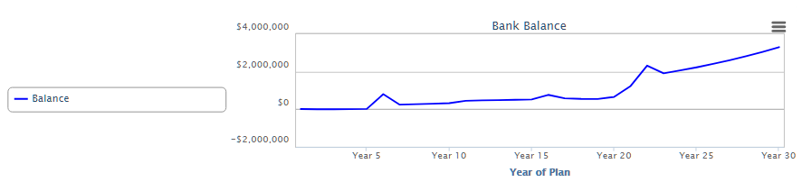

Progress Report: Investment Profile (Excluding Retirement Accounts)
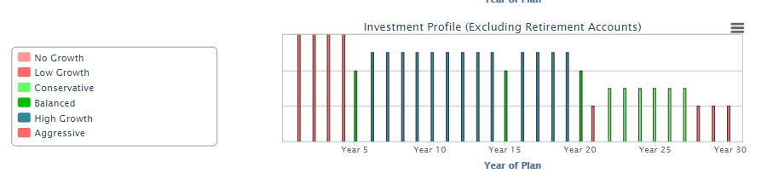

Progress Report: Net Investments & Retirement Funds (FV)
View 1
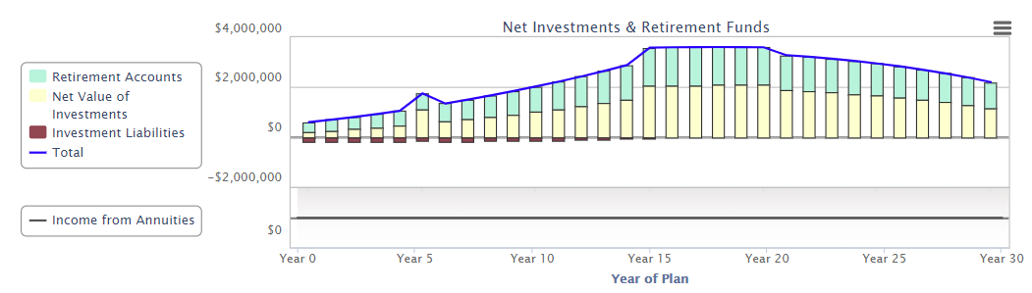

View 2:
Where part of the Retirement Funds are held as an Annuity, the value of the Annuity will be displayed as $0, but the income from the Annuity will be displayed as a sub-graph (both FV and PV)
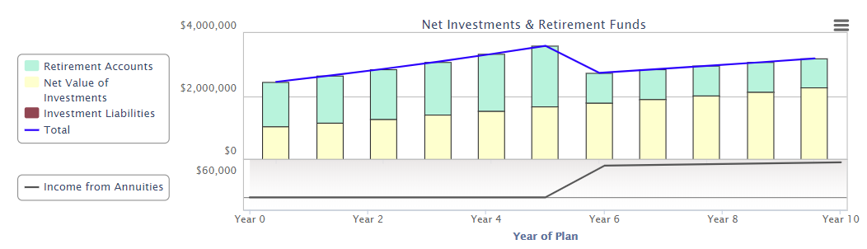

Progress Report: Net Investments & Retirement Funds (PV)

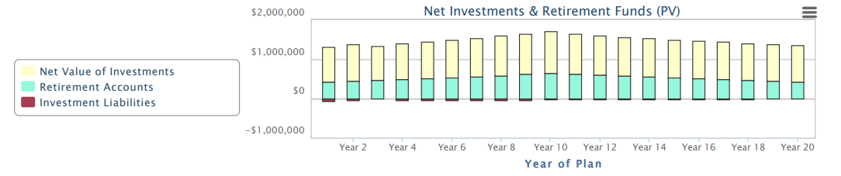

Progress Report: Net Value of Home

Notes:

Where a Home is sold and a new one purchased, the sale is at the end of the previous year to the purchase. Hence you will see a GAP in Year 5, where the property was sold at the end of year 5 and there was no home value until the new home was purchased at the start of Year 6.

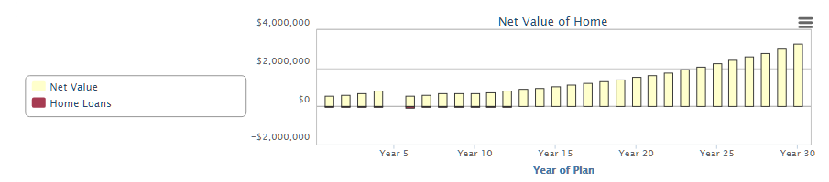

Progress Report: Return on Investments (Including Retirement Accounts)
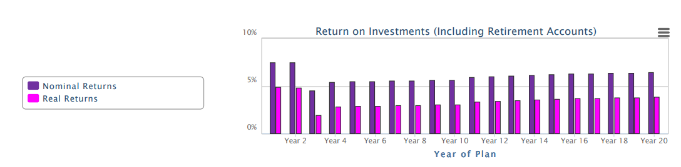

Progress Report: Salaries, Drawdown & Pensions from External Sources (Present Values)

Notes:

In the Retirement Phase, the Drawdown from the Retirement Plan is shown as one value.

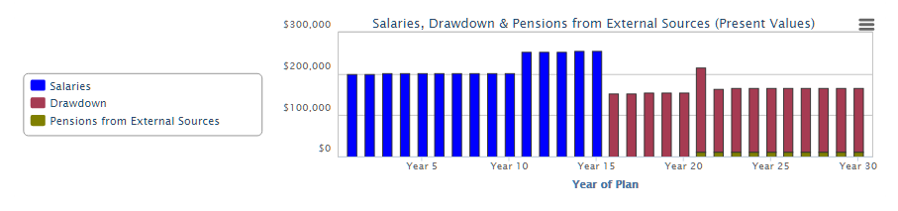

Progress Report: Statistics (Retirement)
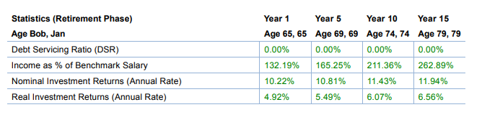

Progress Report: Statistics (Savings)
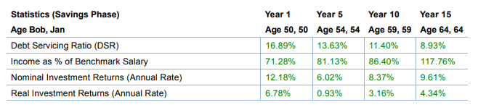

Retirement

Notes:

Each Retirement Account has the Name of the Account in the top left hand corner.

Retirement: Employer Super

AMEND

Notes:
In addition to this SmartPanel, there is one panel for each graph. The SmartPanels are listed as: Super: Name of Graph.
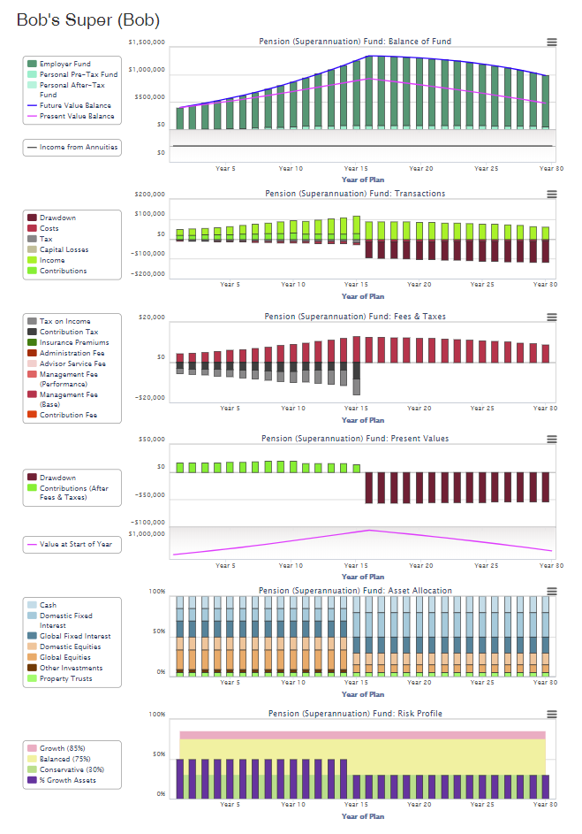
Please note that where the Super account is rolled over to an Annuity at the start of retirement, the value is listed as $0, but the income stream is listed in a sub-graph.

Retirement Plan
The graph may be either PV or FV. The title will indicate where the value is in PV.

Retirement Plan: Drawdown Allocation
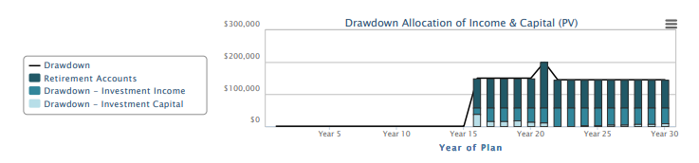

Retirement Plan: Drawdown Funding
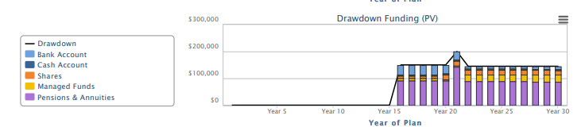

Review

Review ***
The results displayed are for the start of the plan in the PDF file.
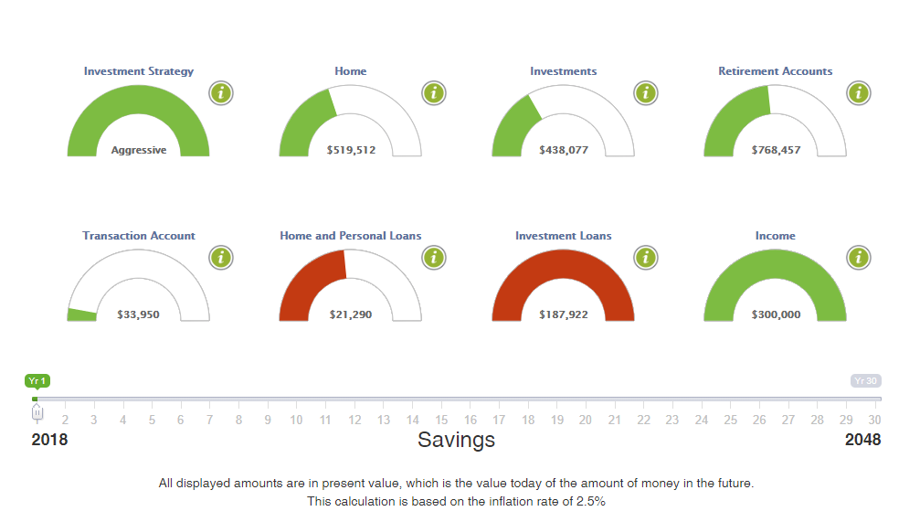

Savings (Investment) Strategy

Notes:

These panels are from the coded report Plan Summary – First 5 Years. Previously it was called the Savings Strategy.

It is particularly useful to identify assets purchased or sold in the first 5-years.

If you want to create a summary of the first-5 years, you may wish to combined some of these panels with those from the Loan Report.

Savings Strategy: Allocation of Savings

Remove TDs & Bonds
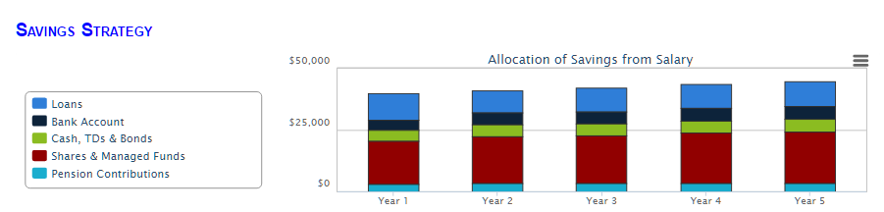

Savings Strategy: Assets at Start of Year

AMEMD

Remove Term Deposits, Bonds & Shares
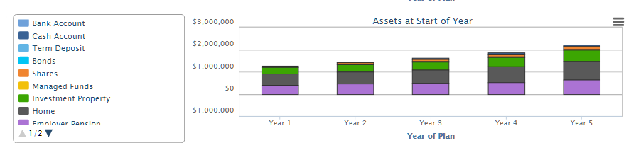

Savings Strategy: Net Assets Graph
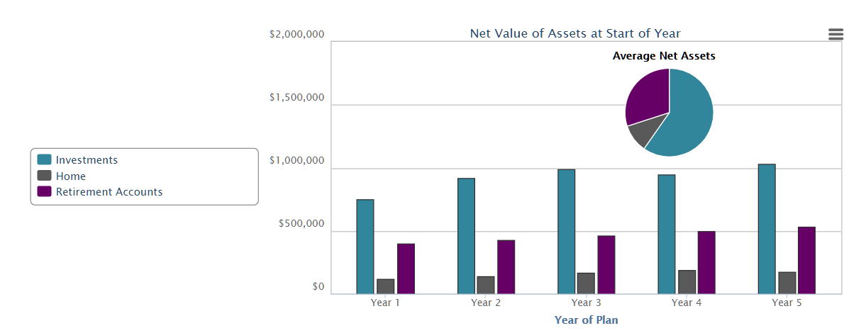

Savings Strategy: Real Estate Purchases at Start of Year
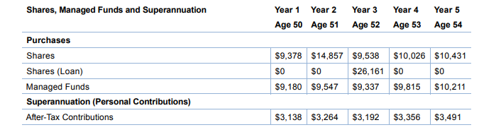

Savings Strategy: Real Estate Sales at End of Year
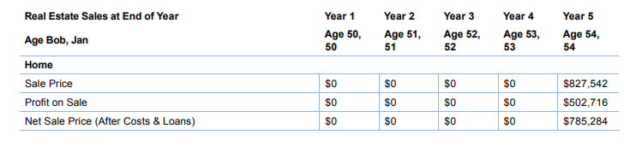

Savings Strategy – Shares, Managed Funds and Superannuation
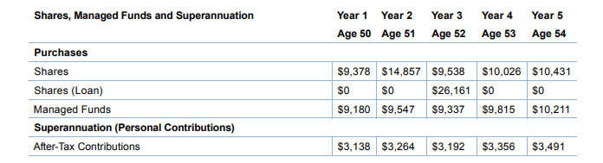

SOA

DELETE ALL PANELS FOR SOA EXCEPT AUTHORITY TO PROCEED & List of Attachments and 9 Custom panels

Notes:

These panels are completely blank and can be formatted with appropriate Headings.

Each of the blank panel has no heading. This means us can use the 19 blank panels for any topic you choose to include. This is a copy of the Blank Panel (Note the level of formatting available)

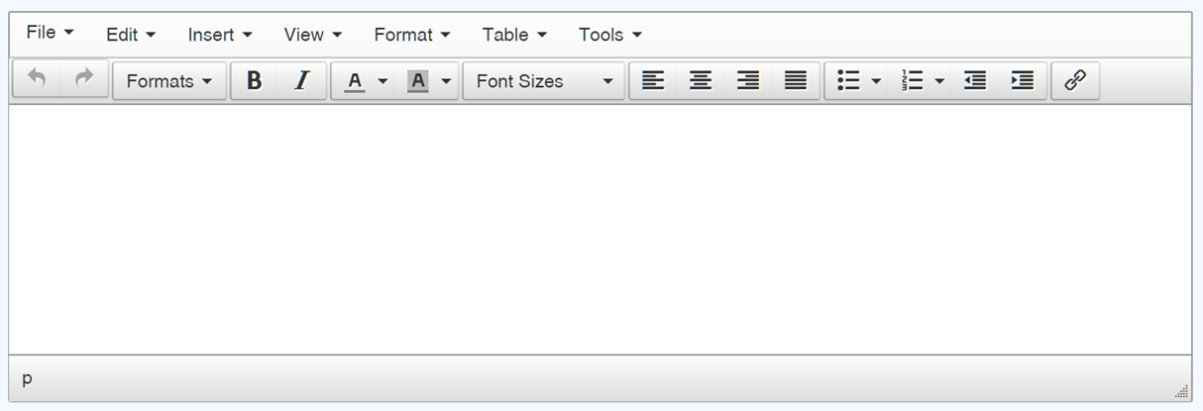

Authority to Proceed is a signing page with the name of the clients and adviser to sign.

SOA: Authority to Proceed

Keep

Notes:
Each Report using this panel, will have the names of the client and the financial adviser.



SOA: List of Attachments

Keep

SOA: Custom 1 – 9

Keep

Summary Report

Notes:

These panels are from the Plan Outcomes which was previously called Summary.

Summary Report: Asset Allocation
The asset allocation shows the allocating according value and to income. This is because there may be times when the plan has a annuity or the super account has been rolled over to an annuity. In these cases, the value of the annuity is $0, however, the income will be displayed in the Income graph. In this screenshot, there are two superannuation accounts, one of which was rolled over to an annuity at the start of retirement.

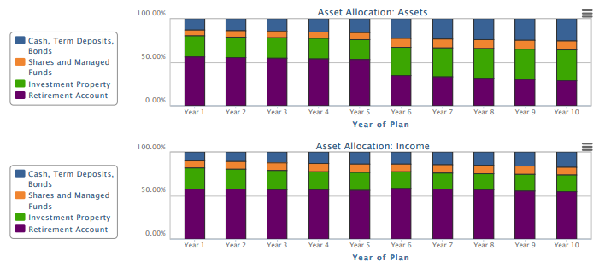

Summary Report: Asset Allocation (Detailed)
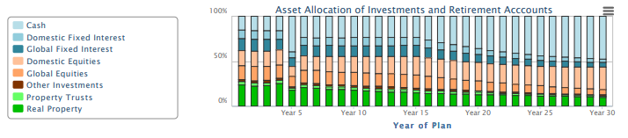

Summary Report: Asset Allocation (Detailed) – Investments
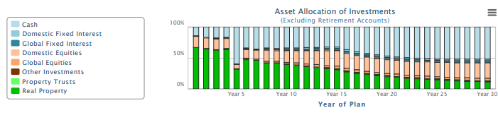

Summary Report: Asset Allocation (Detailed) – Retirement Accounts
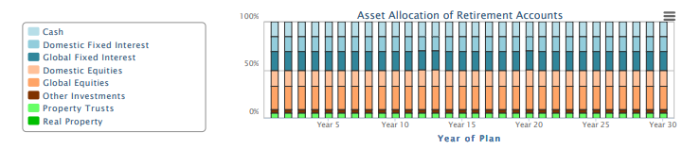

Summary Report – Asset Allocation (Detailed) $ Values
These results are in FV, any PV graphs will include (PV) in the title.
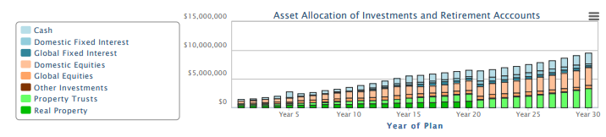

Summary Report – Asset Allocation (Detailed) $ Values – Investments
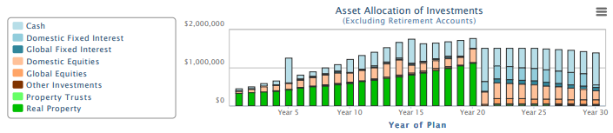

Summary Report – Asset Allocation (Detailed) $ Values – Retirement Accounts
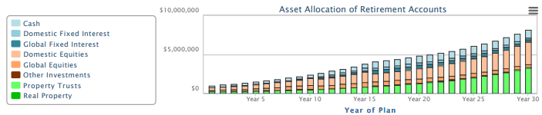

Summary Report – Asset Allocation (Detailed) $ Values (5yr)
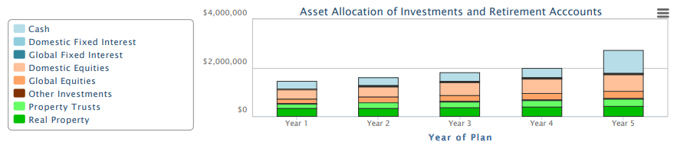

Summary Report – Asset Allocation (Detailed) $ Values (5yr) – Investments
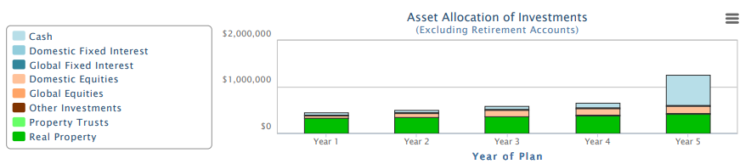

Summary Report – Asset Allocation (Detailed) $ Values – (5yr) Retirement Accounts
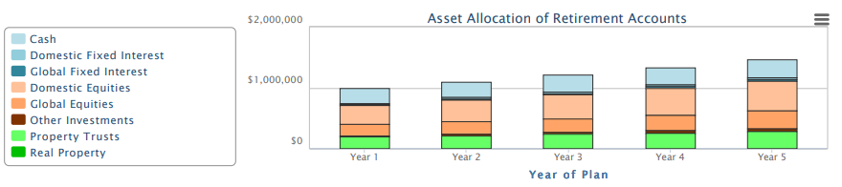

Summary Report: Assets
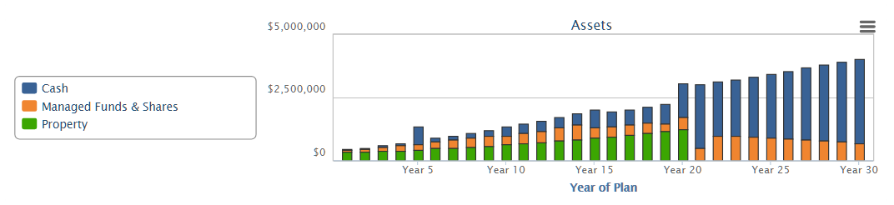

Summary Report: Debt Servicing Ratio
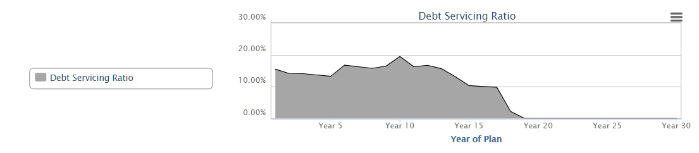

Summary: Investment Profile
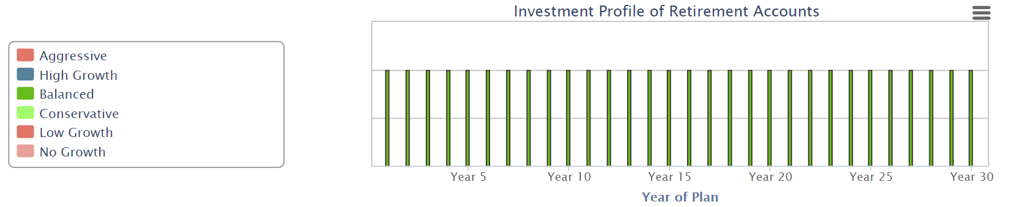

Summary: Investment Profile (Investments)
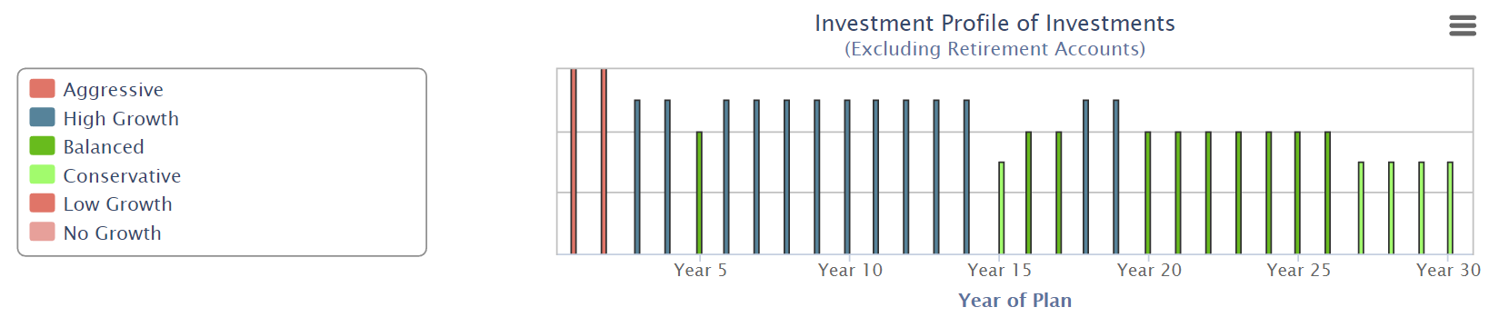

Summary: Investment Profile (Retirement Accounts)
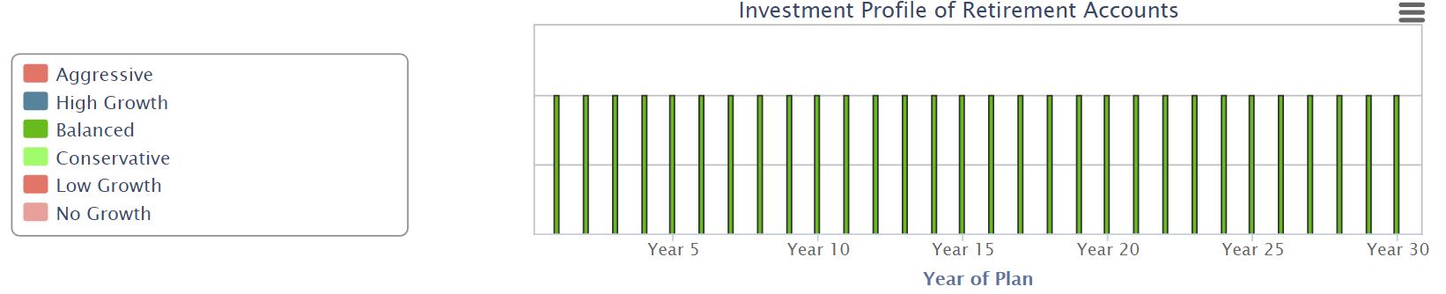

Summary Report: Investment Income
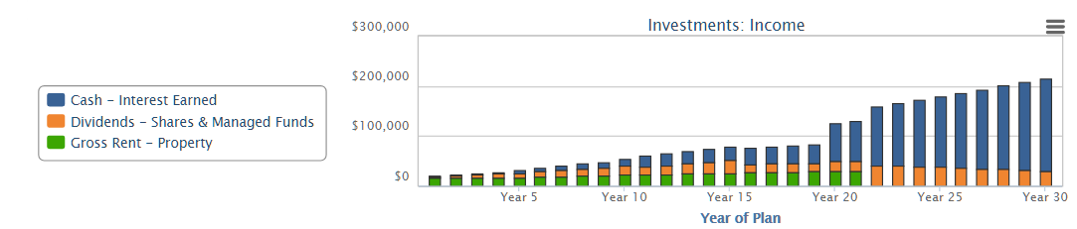

Summary Report: Liabilities
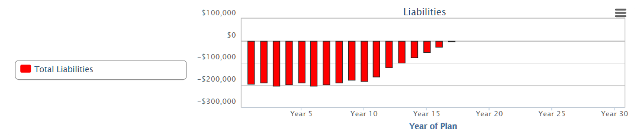

Summary Report: Net Value of All Investments
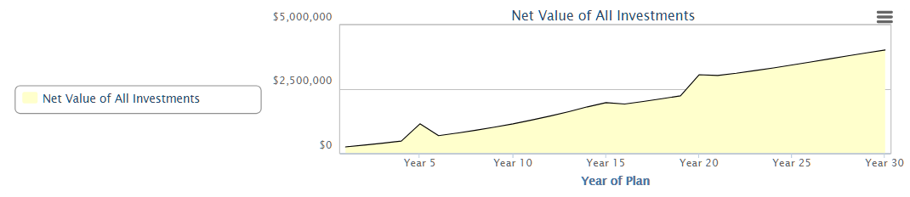

Summary Report: Pensions (External Sources)
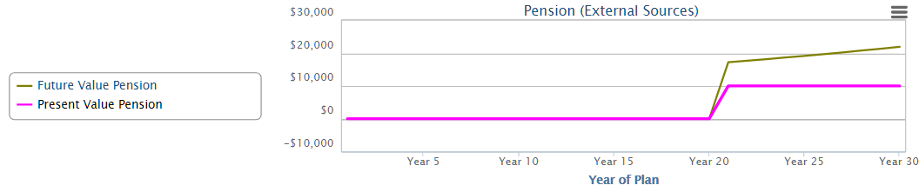

Summary Report: Retirement Accounts Net Value
Where a Superannuation Account is rolled over to an annuity, the annuity has $0. To compensate the income generated by the annuity is listed as a sub-graph. This is a view of where one superannuation account was converted to an annuity and the second was not.

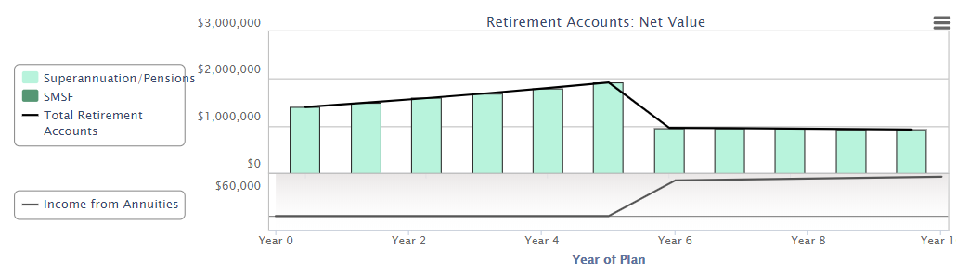

Summary Report – Risk Profile
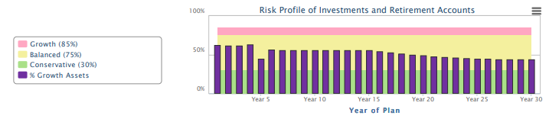

Summary Report – Risk Profile – Investments
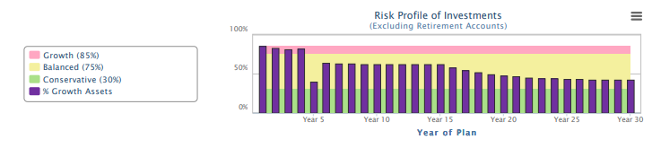

Summary Report – Risk Profile – Retirement Accounts
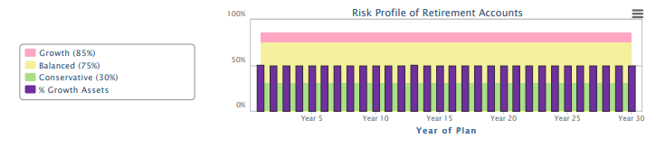

Super

Notes:

These are individual graphs from the Superannuation Account. There is also a panel which has all the graphs in one SmartPanel (Retirement: Employer Super). The name of the Account is listed in the Chart Title. These may be times where each partner has their own Superannuation Account in the plan and a graph for each partner’s account will be displayed. In this example, the Superannuation/Pension Account is called: John’s Old Super.

Super Asset Allocation
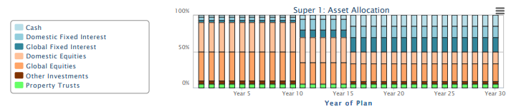

Super: Balance of Fund
View 1:
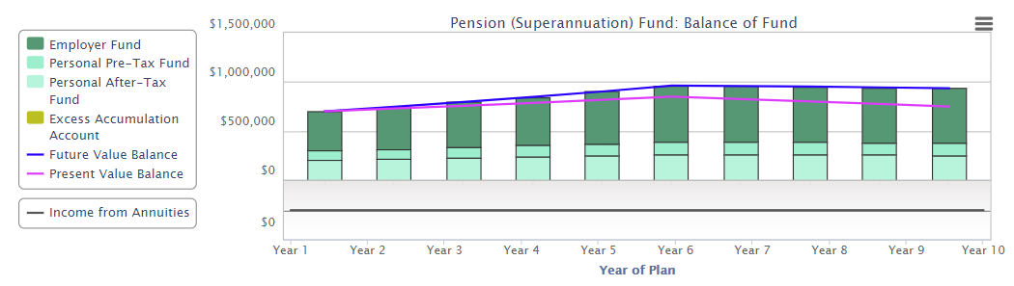
View 2:
Where the account is rolled over to an annuity, the account has $0 value, but the income is displayed as a subgraph. (Note in this case no asset allocation, investment profile or risk profile will be displayed for the period of the annuity)

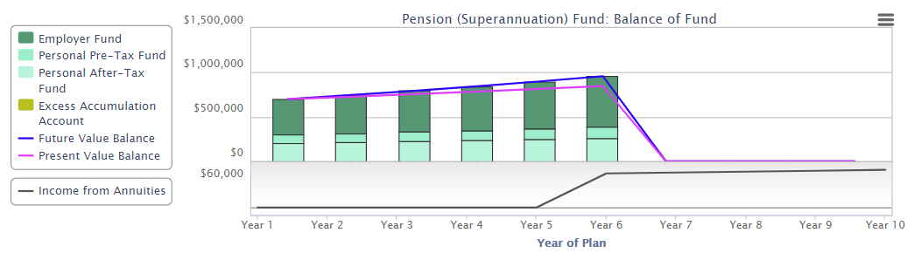

Super: Fees and Taxes
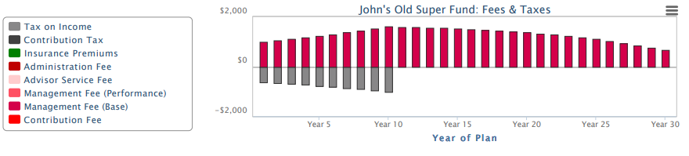

Super Investment Profile
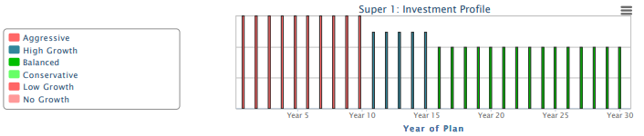

Super: Risk Profile
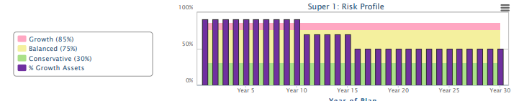

Super: Present Values
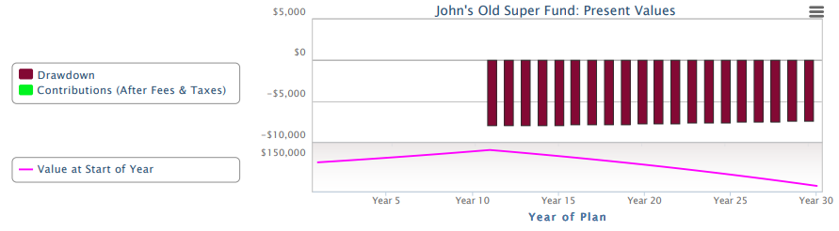

Super: Transactions
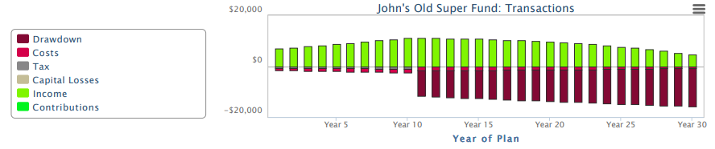

Tax Estimator

Notes:

There are no tables of information from the Tax Estimator.

Tax Estimator: - Estimated Tax Due
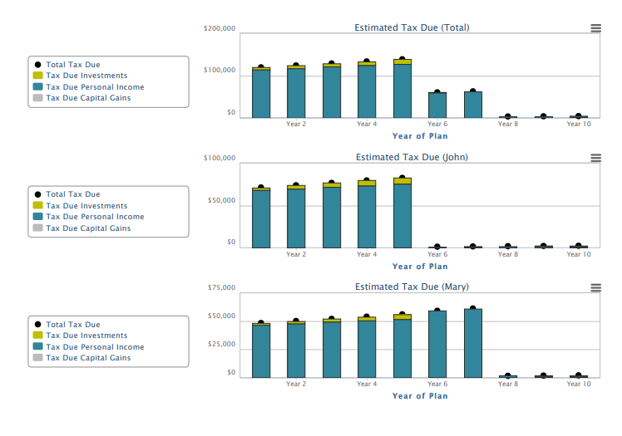

Tax Estimator: Income and Capital Gains to be Taxed
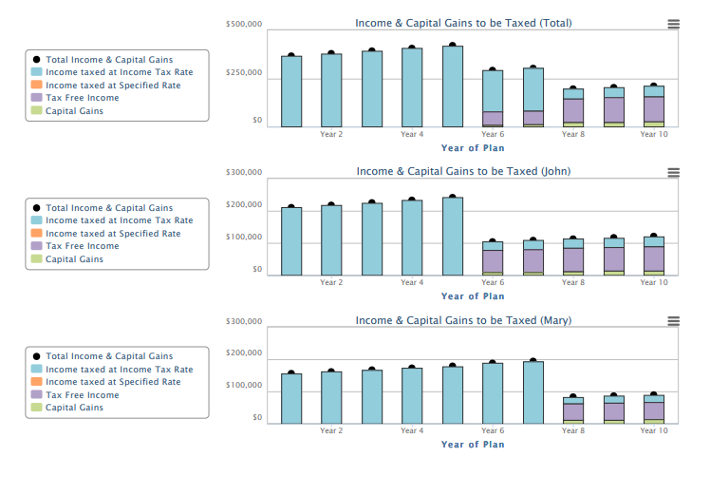

Image Library

These images have been optimized to two sizes - 1000 px wide and 150 px wide.

About our Image Library
With the FPA initiative to make the SOA more engaging for the client, we have created a set of images some of which have been used in our Interactive SmartPanels and in our Money Management Videos.

These images are Royalty Free.

When you are using the SOA Editor panels or creating your Report, you can include any of these images. If you can’t find what you are looking, these images were purchased from Deposit Photos. You will find many more images in this style, if you are looking for something different.
https://depositphotos.com/home.html

These images can be copied and pasted into your Report Builder and SOA editor.

Use the Navigation Pane (View) to find the image you are looking for.

Full List
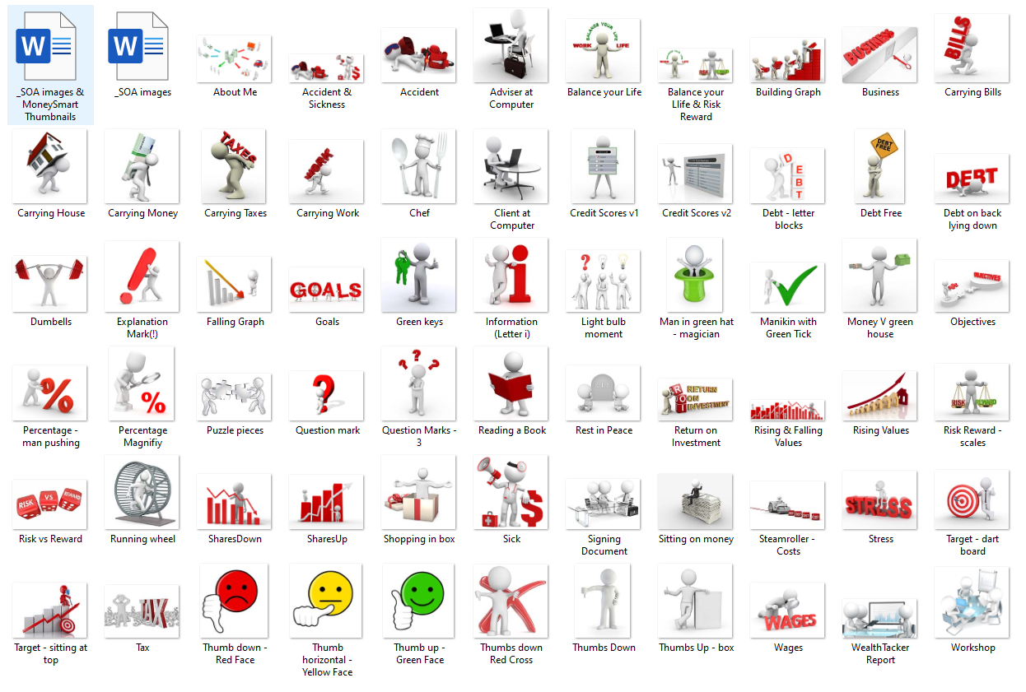

Images
These images have been optimized to two sizes - 1000 px wide and 150 px wide.

About Me
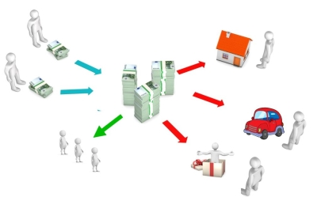

Accident and Sickness


Accident


Adviser at Computer


Balance your Life


Balance your Life & Risk Reward – Scales

Building Graph


Business


Carrying Bills


Carrying House


Carrying Money


Carrying Taxes


Carrying Work


Chef


Client at Computer


Credit Score v1
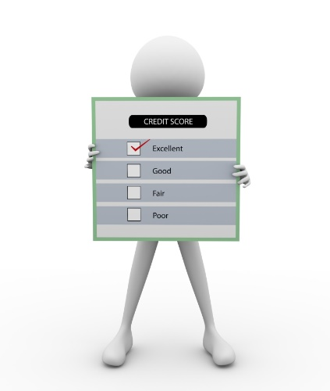

Credit Score v2
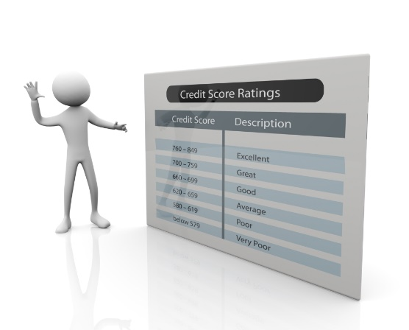

Debt – letter blocks
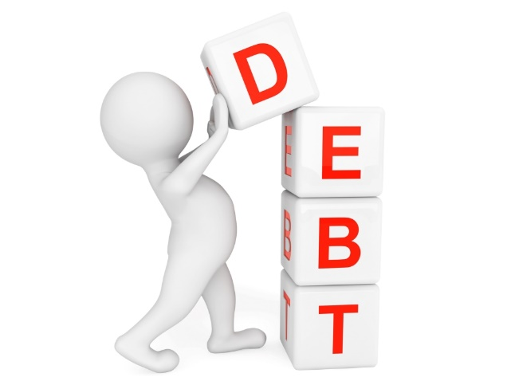

Debt Free


Debt on back lying down
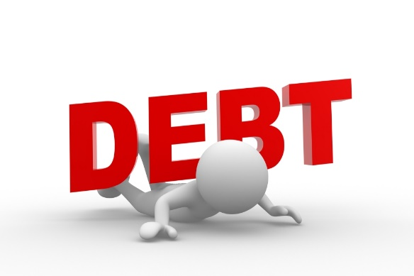

Dumbbells


Explanation Mark (!)


Falling Graph


Goals


Green Keys


Information (Letter i)


Light bulb moment


Man in green hat - magician


Manikin with Green Tick


Money V green house


Percentage – man pushing
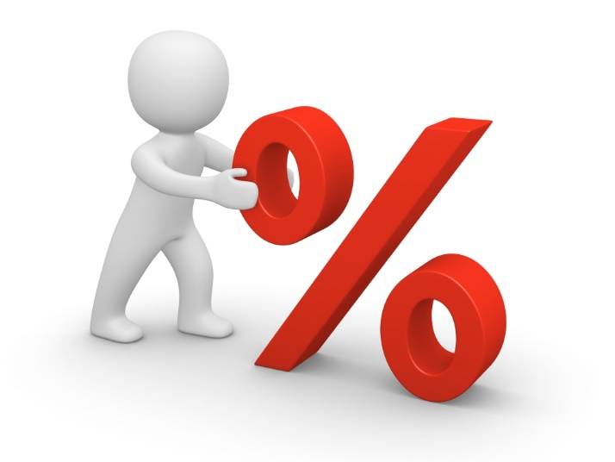

Percentage - magnify


Puzzle Pieces


Objectives


Question Mark


Question marks - 3


Reading a Book


Rest in Peace


Return on Investment


Rising & Falling Values


Rising Values


Risk Reward - scales


Risk Vs Reward


Running wheel


Shares Down


Shares Up


Shopping in box


Sick


Signing Document


Sitting on Money


Steamroller -Costs
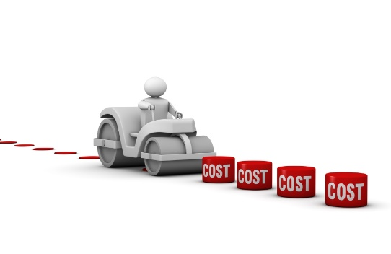

Stress


Target – dart board


Target – sitting on top


Tax


Thumb down – Red Face


Thumb horizonatal – Yellow Face


Thumb Up – Green Face


Thumbs Down – Red Cross


Thumbs Down


Thumbs Up - box


Wages


Wealth Tracker Report


Workshop


Excel and Data Tables

Please note that any Data Table can be copied to:
- Excel
- SOA Editor panel
This is an example from the Cash Flow Summary, where the income has been copied into an Excel File

In addition, any Data Table in a SmartPanel can be copied to an Excel Workbook:

