# Introduction

Once you have discussed Advice Online with Glenis Phillips, the designed of Advice Online, you will be sent a contract from Plencore Online Pty Ltd. When this is signed you will be invited to create your white-labelled platform to use Advice Online. There are no fees to pay until you start giving advice to your clients.

This will be the process:

1. Your **Administrator** will then be sent a link to set up and customise your created Advice Online installation.
2. The **Administrator** should copy and publish the three Template Reports, called Advice Record. It is important that these reports are made ‘Visible to Client’. After reading the Overview document you will know how and why you can create more reports using the Report Builder
3. The **Administrator** invites those advisers and paraplanners using the software to register as users. Once registered, advisers can create clients and commence the planning process.

# Role Descriptions

The **Administrator** role is the highest level of capability and has ***exclusive access*** to the following software usage functions:

* Registration of the company’s unique sub-domain name (the first section of the permanent website URL for the company’s unique **Advice Online** account).
* Specification of Company settings where the company’s logo and color scheme together are nominated along with the wording of the company’s **Disclosure Statement** (which appears on all reports).
* Setting of the company’s default rates (that is – all rates used in the calculations unless changed to “**Specific Rates**”).
* Creation of any additional company specific reports via the Report Builder. It is recommended that initially all three Template Reports are copied, Published and made visible to the client. These can be modified as required or the Chief Administrator may create new reports. The client does not have access to these reports until the adviser has published the Advice.
* Appointment of additional Chief Administrator roles via the “Users” screen. It is recommended that any additional appointments only be made for as long as required for a particular person to perform a specific task such as the creation of a report template via the Report Builder.

The **Administrator role** alsohas access to all functions included in the Admin, and Adviser roles. (You can elect to have more than one Chief Administrator role, and the roles can be changed, however it is recommended you keep the number of people with this role to a minimum)

This means the **Administrator** role can also do the following:

* Invite specific Advisers and Paraplanners to each register an **Advice Online** account within the company’s **Pro** system.
* Edit the details of Clients including the closing of the account.

The nominated **Administrator**  will be sent an email with the link where they can create and set up the company’s **Advice Online** account.

To create and customise your **Online Advice** account the Chief Administrator follows these steps:

## Account Creation

When the **Administrator** receives an email from Advice Online, with link to the **Advice Online REGISTRATION**, they complete the online registration form shown here.

*Note on Subdomain:*

*The subdomain cannot be changed, and it is important that a short name be chosen which easily identifies the URL with your company.*

In the case of our demonstration platform, the URL is <https://goodadvice.adviceonline.net.au>

It is important that only the person nominated for the role of **Chief Administrator** completes this form.

* First Name
* Last Name
* Email (Username)
* Confirm Email
* Company Name
* ABN
* Subdomain (URL Prefix)
* Billing Address
* Email for Billing
* Address Line 1
* Address Line 2
* Suburb
* State and Post
* Country
* Agree to terms.

The **Administrator** will then receive via email a link which will take them to a page to set their password.

The **Administrator** then receives an email to confirm that registration has been successful. They can then then log into their newly created **Advice Online** account using their username (email) and password.

## Account Customisation

Only the Administrator has access to the Admin section of the software and is not displayed for other account holders.

#### Company

When creating reports, there are a choice of two Placeholders – Company Name and Application. The Application Name is the name at the top of each page and is usually a shortened version of the full company name.

It is here the logo and favicon are uploaded.

#### Styling

This is the page where you customize your colour scheme. This is the default which uses the primary colour blue.

If your company’s primary colour scheme is green, you may select this option. Note that apart from the primary colour, other options are kept to shaded of grey so they will fit with most colour schemes, but these can be changed as well.

You can always come back and modify once you are familiar with your platform.

#### Personal Tax

The tax information defaults to the current defaults for Australia. The 2.00 % Flat Tax accounts for the Medicare Levy.

Where the software is being used in another country, select the Country and the current Year for the Tax Table. These are updated when new rates have been activated.

#### Capital Gains Tax

The Capital Gains Tax defaults to that of Australia.

The other options are No CGT as in New Zealand, or a Percentage of Capital Gain.

#### Superannuation

Currently there is the selection of two Country Specific Superannuation/Pension types. The default is Australian Superannuation. KiwiSaver is the second, but it is anticipated that others will be added shortly.

#### Disclosure Statement

The Disclosure Statement is prefilled with a Disclosure Statement.

This is draft version, but you should consult with your legal team as to the suitability for your practice and level of advice you are giving from Advice Online.

The Disclosure Statement is included on the front page of all reports.

# Default Rates Entry

Select each Tab to review and reset the Default Rates. These Default Rates are applied to every account holder using the company’s **Advice Online** account. That is - all Advisers, Paraplanners and Clients will always use these company-specific Default Rates.

The Default Rates are based on the approximate 20-year average returns from Year 2000.

Inflation: 2.50% (This rate is an ASIC requirement)

Returns

Cash Accounts: 5.18% (90 Day Bank Bill + 1%)

Shares: 10.37% (Dividends 4.25%, Capital Growth 6.12%)

Property: 10.37% (Net Rent 4.25%, Capital Growth 6.12%)

Managed Funds: 10..37 (Dividends 4.25%, Capital Growth 6.12%)

Superannuation Returns: 7.00% (Pre-filled entry per plan – not a default rate)

Loan Interest

Principal & Interest Loans

Home Loans: 6.67%

Investment Property: 6.67%

Shares: 7.67%

Personal: 9.67%

Interest Only Loans

Home Loans: 7.17%

Investment Property: 7.17%

Shares: 8.17%

Personal: 10.17%

Credit Cards

Purchases Rate: 15.00%

Introductory: 3.00%

Note that for Shares and Property, the average of the two have been applied to both.

It is recommended that you decide very early what default rates you want to use for your company. As a guide these are average rates over various time periods.

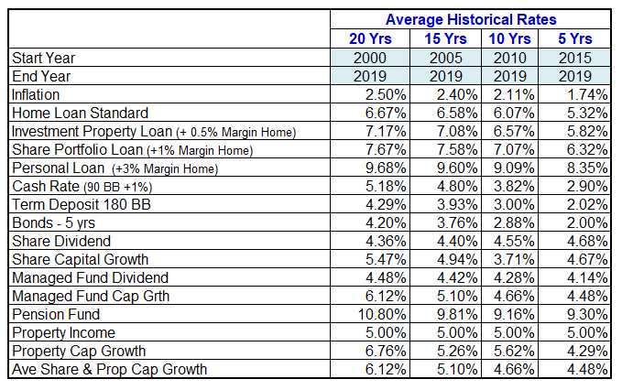

# Reports

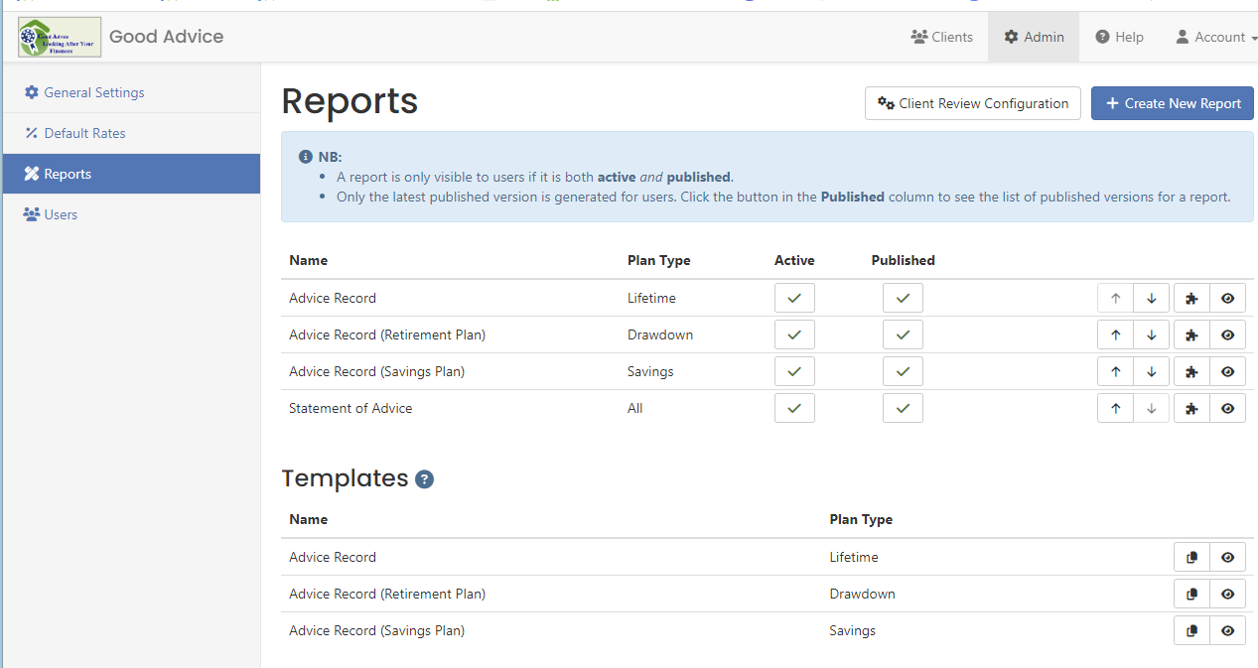

The software provides three versions of an Advice Record. The company can edit versions, but it is believed that the format will suit most companies wanting to provide low-cost advice.

The process is:

* Copy Template Report
* Edit if required
* For the Advice Record Reports, click on the name of the report and select “Make Visible to Clients”. When the adviser has completed their plan and generated their Advice Record, the applicable version of the Advice Record will be visible to the client.
* To complete you must “Publish” the report. This must be repeated whenever you change content in the report.

It is important that you only have one Advice Document visible to the client. You should save this document as a PDF and add to the client’s Connect Portal.

If the company chooses to have other versions of Advice Documents, such as the current SOA as required by the government, you can create this report and then share that Advice Document in the Connect Portal. Until such time as the government clarifies the situation regarding SOA’s you may have two documents.

# Users

Only the Administrator has access to the list of users.

# Adding Users to the Advice Online Platform

The **Administrator** now adds any other team members who will be creating or adjusting plans for their clients. This is done by inviting the nominated advisers or paraplanners to register.

These team members are given the role of either **Adviser** or **Admin**.

The **Administrator** must first go to **Users** page, in Admin.

The **Administrator** should also invite any **Paraplanners** who will work on client plans on behalf of the Adviser.

Each invited **Adviser** and **Paraplanner** receives an email to register an account within your company’s Advice Online platform.

Each Adviser will invite their clients and manage the Advice Episode.

An Advice Episode lasts from 2-months, commencing from when the adviser receives the Client’s Fact Find. During that time, they can create any number of Advice Documents and update the plan. The company will be billed at the end of each month for all Advice Episodes commenced in that month.

The Adviser may share a client’s details with another adviser or paraplanner, where they edit directly into the plan and create reports.

When the work has been completed, the adviser can unlink the adviser or paraplanner and they no longer have access to the client’s information.

# Contact

All correspondence should be restricted to Glenis Phillips SF Fin, Designer of Advice Online.

Email: [glenis.phillips@plencore.com.au](mailto:glenis.phillips@plencore.com.au)

[admin@adviceonline.net.au](mailto:admin@adviceonline.net.au)

Phone: (07) 3216 4132

0411 086 532

1300 162 945

Zoom [Calendly](https://calendly.com/glenis-phillips-advicenline/60min?month=2023-11)